2nd September 2024

Dear Parents & Carers

**A letter to parents and carers whose children have started attending a Church of England school**

I am writing to you as the Chair of the Peterborough Diocesan Board of Education, which oversees all Church of England Schools in this area. Thank you for choosing a Church of England school for your child. We hope that your child’s first term will go well and that the time ahead will be happy and fulfilling.

Christians believe that, wherever we come from and whatever our beliefs, everyone is included in the unconditional love of God. If you want to get a glimpse of what God is like, look at the life of Jesus; he gave unconditional love, forgiveness, hope, justice, purpose and a future to those who encountered him, and he tells us to do the same for those we meet. In the Bible, the only precise definition of God is *“God is love.”* Later in the Bible, we read that, *“Love never gives up, never loses faith, is always hopeful, and endures through every circumstance.”* So it is no surprise that Jesus said that the two most important things in life are to love God and love one another.

Church of England schools are inclusive places that warmly welcome Christians or those of other faiths or those of no faith. Everyone is equal. All children are welcomed and valued for who they are. Historically, many Church of England schools were established for the benefit of local children as places where all were able to learn and flourish in a secure and supportive environment. As a child, I attended a Church of England school, as did my wife and, years later, our children. Now our oldest grandchild is in a Church of England School. These schools are a great foundation for life. You will soon find out more about the positive links that your school has with your local church and the ways they can support you as parents or carers.

We hope you will find that the unconditional love of God is a reality in your school.

Yours faithfully

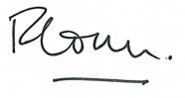 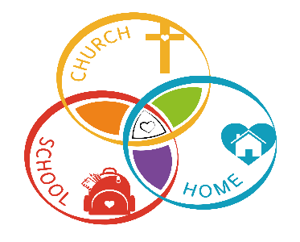

The Venerable Richard Ormston

Archdeacon of Northampton and Chair of the Peterborough Diocesan Board of Education