
BISHOP’S LETTER 31
15 July 25

Dear Friends,

The last few weeks have given me pause for thought.

At the end of June, I celebrated forty years as a priest and while in some ways just another notch on the calendar, such markers inevitably invite you to look back at the journey you’ve undertaken.

In 1985 the world was a very different place. The very first (very clunky) mobile phones, were just coming on to the market, the internet wasn’t a thing, there were no emails arriving in inboxes at all hours of the day and night! Mikhail Gorbachev had just become leader of the Soviet Union and although it wasn’t clear at the time; the so-called ‘Iron Curtain’ was about to be torn down. We looked forward to (rather than feared) the occasional hot summer.

The Church was also very different. We weren’t competing with Sunday trading and a myriad of other leisure and sporting events. All our clergy were male. Initiatives of the national church such as the Faith in the City report were considered important voices in the debate about the well-being of the nation, in a way that would be hard to imagine, given the attempts to marginalise the Church that we see now even over critical moral questions such as assisted dying.

But our challenge, and not least for Bishop Debbie and the Bishop’s Management Group, is not to look wistfully back, but plan with hope for a future that is, in any case, in God’s hands. New times call for fresh thinking and, in some cases, new structures, and a lot of work is underway to make our Diocesan governance and structures more effective, inclusive and accountable, and to release energy for mission in our communities. For all that, the enduring message of the Gospel and of God’s love for all his children, remains the same. Christ is our cornerstone – on him alone we build.

With every blessing

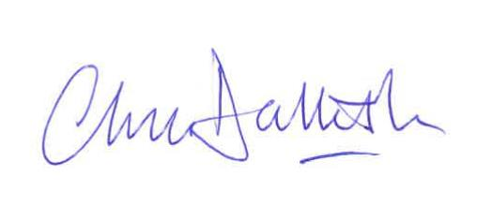
The Very Reverend Chris Dalliston
Dean of Peterborough

