Castor Benefice Profile

The Benefice of Castor with Upton and Stibbington and Water Newton, Marholm and Sutton

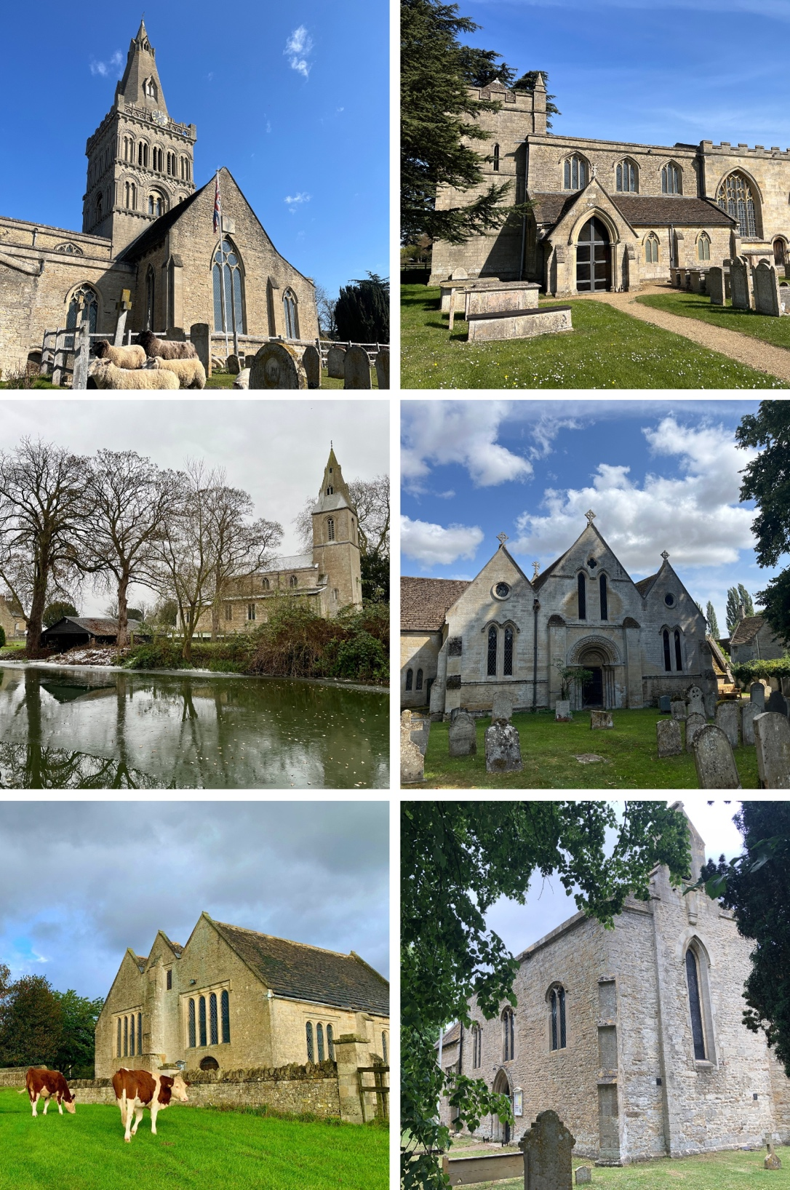

2025

Welcome to our Church

Welcome, and thank you for taking the time to explore our profile and learn more about the Castor Benefice.
We are a vibrant and inclusive group of six churches across three parishes: Castor with Upton, Stibbington and Water Newton; Marholm; and Sutton. Rooted in the Liberal Catholic tradition, our benefice values Eucharistic worship, pastoral care, and community life.
This vacancy follows the retirement of our previous incumbent, who served faithfully for ten years and oversaw a period of growth and renewal. We are grateful for the strong foundations that have been laid and are excited about the opportunities that lie ahead.
We are seeking a new Rector who will lead with warmth, wisdom, and vision — someone who will share in our worshipping life, deepen our pastoral care, and work with us to grow the church across our communities. You’ll find a well-resourced benefice, a dedicated team of lay and ordained colleagues, a strong local school, and a welcoming home at the heart of a thriving village.
We hope this profile gives you a rich and honest picture of who we are, the gifts we bring, and the ways in which we are seeking to grow. We look forward to meeting you.
The Churchwardens and PCCs of the Castor Benefice

Contents

Welcome to our Church 2
Contents 3
Our Vision and Mission 4
What we can offer you 5
Our Parish 6
Our Church 8
Our Worship 10
Our Church Community: Congregation 14
Our Children, Young People and Families 15
Our Groups 17
Our Team 19
Our Finances 21
Our Organisation 22
Our New Rector 24
A place to call Home 26
A position for you? 27

Our Vision and Mission
Our vision is to be a welcoming, inclusive and Eucharist-centred benefice, rooted in faith and tradition, committed to growing spiritually and numerically across our churches and communities.
We identify strongly as a Liberal Catholic benefice, with worship centred on the Eucharist and the rhythm of the Daily Offices. We place great value on thoughtful, well-planned liturgy and music, and are deeply committed to pastoral care, particularly for the sick, elderly and bereaved.
We believe the future of our benefice lies in nurturing the whole church family — especially children, young people, and families. We have active programmes of ministry to support this such as Children’s Church, Family Praise, and our First Communion and Confirmation work. In addition, recognising that we have older members of our congregation, we work hard to provide a range of more traditional services to suit their spiritual needs.
As we look to the future, we aim to:
- Deepen our spiritual life through rich and inclusive worship
- Strengthen and grow our work with children and families
- Care for all who live in our parishes through meaningful pastoral outreach
- Build the benefice as one community while respecting the character of each church.

Theological Conviction Statement
The PCC affirms the ministry of ordained women and men and embraces the full inclusion of all people, regardless of age, gender, status, or sexuality. We baptise infants and adults, admit children to communion before confirmation, and marry divorcees. We are proud to be described as “inclusive, compassionate and informed”.

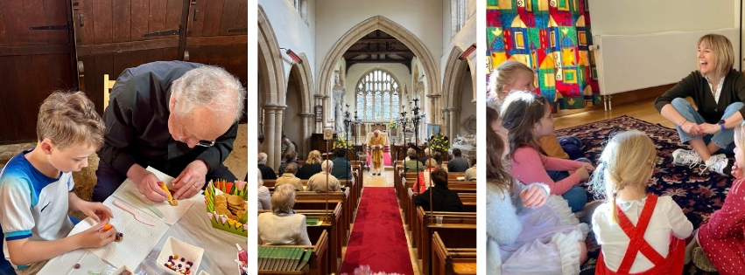

What we can offer you
We believe that a joyful and fruitful ministry is rooted in mutual support, shared vision, and strong community. As a benefice, we are committed to walking alongside our new Rector and offering:
- A welcoming and supportive church family, deeply committed to worship and community life
- A collaborative and capable team of lay and ordained leaders, including a voluntary Children’s worker and retired priest.
- A thriving and engaged congregation, enriched by children, families, and long-standing members alike
- A well-resourced benefice, including a four bedroomed Rectory, a modern church hall (The Cedar Centre), a part-time Benefice Administrator, and a cloud-based church management system (ChurchDesk)
- A strong ethos of pastoral care.
- An inclusive worshipping tradition, supported by an active robed choir, children’s choir, bell ringers, organist, and lay-led family services
- A lively Children’s Church and Family Praise programme, offering real opportunities for growth
- Close and active links with Castor Church of England Primary School, a highly regarded village school with regular services and shared ethos
- A proven commitment to working across parishes, respecting each church’s character while building a shared identity
- Well-maintained historic buildings, supported by active volunteers and Friends groups
We also offer honesty and realism: we are aware of the challenges ahead, particularly in reaching young people beyond primary school age, sustaining volunteer capacity, and strengthening unity across the benefice. But we are ready to meet those challenges with energy, hope, and prayer — and we look forward to doing so with you.
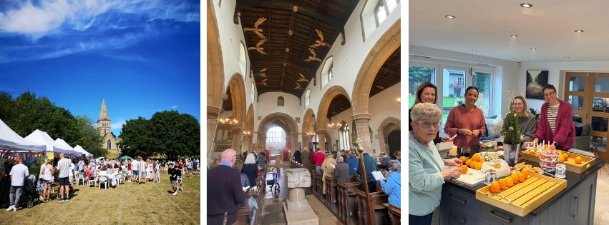

Our Parish
The Castor Benefice is a group of six churches across three parishes:

- Castor with Upton, Stibbington and Water Newton
- Marholm
- Sutton

We are part of the Deanery of Peterborough in the Diocese of Peterborough, situated just west of the city. The benefice offers the best of both worlds: the warmth and identity of rural village life, with excellent connections to Peterborough, Cambridge, and London.

Our communities are deeply rooted in Christian tradition and are committed to being places of worship, welcome and witness. Following a successful merger of parishes from the Diocese of Ely and the Diocese of Peterborough, we now operate as a unified benefice with Castor at the heart, and strong collaboration between all churches. Upton, Stibbington and Water Newton now function as chapels of ease within the parish of Castor.

Living and Thriving Here

The Castor Benefice is a special place to live and minister. Our villages are welcoming, outward-looking, and full of life. Many families have lived here for generations, while others have joined us more recently, drawn by the balance of rural charm and city access. The result is a lively and engaged community, where people of all ages contribute to village and church life.
Key features of our community include:

- A population of around 3,000, spread across distinctive and close-knit villages
- A range of housing from historic stone cottages to modern family homes
- Sports facilities including a tennis club, a cricket club and a football club
- Two vibrant and popular village pubs and a fine dining restaurant
- A strong tradition of volunteering and civic pride, with active parish councils, community groups, and events
- Beautiful, listed churches and churchyards, treasured as spiritual and community landmarks

The benefice is just a few miles from Peterborough city centre, offering:
- 45-minute train journeys to London King’s Cross
- Major retail, leisure, and healthcare facilities
- Excellent state and independent schools
- Access to regional transport, green spaces, and the River Nene

This is a place where ministry is visible and valued, and where the church is at the heart of village life.

Schools and Education

We are blessed with excellent educational links:
- Castor CE Primary School, located next to the church, is a highly regarded and oversubscribed school with a strong Christian ethos and regular involvement in worship. It was rated Good in all areas by Ofsted in 2024 and plays a central role in our ministry with children and families.
- Many pupils go on to The King’s (Cathedral) School or Arthur Mellows Village College — both rated Outstanding by Ofsted.
- There is also a strong home learning and post-16 education culture, with easy access to sixth form colleges and universities in Peterborough and Cambridge.

Health and Amenities

- Local GP surgeries are available in Wansford, Ailsworth, and nearby Bretton.
- Castor Lodge Care Home offers residential and dementia care and is supported by our pastoral care team
- Peterborough offers access to full hospital and specialist healthcare services

Ecumenical Links

We enjoy good relationships with neighbouring parishes and other Christian denominations. While rooted in the Liberal Catholic tradition, we value ecumenical dialogue and collaboration, and contribute to the diverse life of the Deanery of Peterborough.

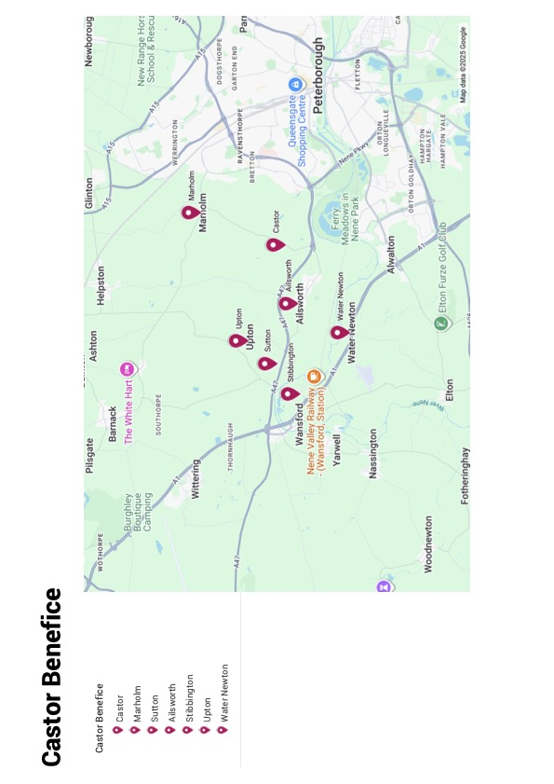

Our Church
Our six churches are varied in character, but united in purpose. Each has its own story and community, but we worship, plan, and grow together as one benefice.

St Kyneburgha’s Church, Castor
St Kyneburgha’s is the spiritual and administrative heart of the benefice and a site of national significance. A Grade I listed Norman church with Saxon and Roman origins, it celebrated its 900th anniversary in April 2024, marking nine centuries of Christian worship on this sacred site.
Highlights include:
- A celebrated Romanesque tower, described as “probably the finest Romanesque parish church tower in England”
- Norman and medieval carvings, including a Saxon ‘Christ in Majesty’ and a medieval wall painting of St Catherine
- A 15th-century angel roof, featuring around 60 carved figures
- Recognition as one of England’s 100 finest churches, according to the author Simon Jenkins praised for its history, artistry, and architecture
The church stands on the site of the former Roman praetorium and was later home to a 7th-century convent founded by St Kyneburgha, daughter of King Penda of Mercia.
Today, St Kyneburgha’s is home to a vibrant choral and Eucharistic tradition, a multigenerational congregation, and is open daily for prayer and reflection. The church hosts regular worship, civic and diocesan services, and school events, and benefits from excellent facilities including disabled access, livestreaming, a modern sound system, and the adjacent Cedar Centre — a flexible hall used for children’s ministry, meetings, and community groups.

St Mary the Virgin, Marholm
St Mary’s is a peaceful, well-loved church at the heart of the village, with a small but faithful congregation. This Grade I listed building offers a regular rhythm of Eucharistic worship and is closely tied to village life. Its rural setting, simple beauty, and welcoming community make it a valuable and prayerful part of the benefice.

St Michael and all Angels, Sutton
This is a much-loved rural church, modest in size and with no fixed seating making it a flexible space for local groups. Sutton church isn’t only a place of worship; it’s been a community facility for a number of years and plays a key part in supporting many positive aspects to village life. The churchyard is beautifully maintained, and the church is well cared for by a loyal group of parishioners. It also boasts a kitchen and toilet facilities.

Upton, Stibbington and Water Newton
These three churches are chapels of ease within the wider parish of Castor. They host services at major festivals and for occasional offices, supported by Friends groups and volunteers.
- St John the Baptist, Stibbington: A simple and atmospheric building, holding 5 regular services each year supported by a small and friendly congregation who enjoy a more relaxed service such as their ‘Pancake Sunday service’. Local school children also can enjoy our church in conjunction with The Nene valley railway on WW2 Evacuation Day organised by Burwell house.
- St John the Baptist, Upton: Currently undergoing roof repairs. It is hoped that the church will be transferred to a church conservation trust and will no longer be used for regular worship. It remains part of our heritage, and we are committed to its long-term care and preservation.
- St Remigius, Water Newton: A tranquil riverside church with Roman heritage. It is maintained by the Friends of St Remigius, a small group of committed volunteers who have recently secured repairs to the roof. Services here are particularly popular in the summer months and during special festivals. The church is the only community space in the village, and therefore the commitment to maintain it as a place of community and worship is strong.

Benefice Character
Across the benefice:
- Our churches are safe, clean, and well cared for
- Maintenance is supported by Friends groups, parish volunteers, and clergy oversight
- Each church reflects the distinctive identity of its village, but all share a commitment to welcome, beauty, and sacred purpose
While Castor holds the majority of regular services, all six churches contribute to the spiritual rhythm of our community, offering spaces for reflection, celebration, and belonging. Together, they form a rich tapestry of worship and witness.

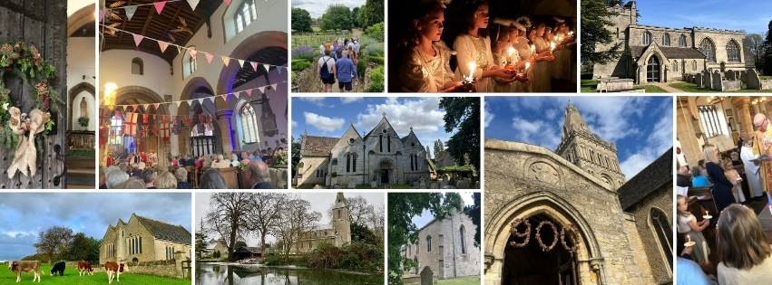

Our Worship
Worship is at the heart of our benefice. Across our six churches, we are committed to offering regular, reverent, and inclusive worship that reflects our Liberal Catholic tradition and supports people at all stages of faith.

Worship Style and Tradition

The Eucharist is our principal act of worship, celebrated with care, music, and reverence. Services follow the Church of England lectionary and Common Worship, and are supported by strong lay involvement, particularly in readings, intercessions, and music.
We value both the depth of tradition and the flexibility to include families and newcomers, especially through our Children’s Church and all-age services.

Weekly Worship Pattern
We offer a regular and varied pattern of worship across the benefice. Key elements include:
- Sunday Eucharist at St Kyneburgha’s, Castor (typically 8.00 and 10.15 AM) (Marholm 9.00 AM BCP or Common Worship)
- Midweek services, including Wednesday morning Eucharist and seasonal observances
- Festival and special services in all churches (Advent, Christmas, Holy Week, Harvest, Remembrance)
- Occasional services (baptisms, weddings, funerals) across all parishes
- Chapels of ease host worship at key times of the year
Our calendar includes joint benefice services, civic commemorations, and school-led worship — particularly through our close links with Castor CE Primary School.

Children’s Church
Children’s Church is a lively and distinctive aspect of our worship life. It runs every Sunday during term time at St Kyneburgha’s and is:
- Led by a dedicated team of volunteers, many with teaching backgrounds
- Based in the Cedar Centre, which offers a warm, flexible space for creative worship and learning
- Aligned to the lectionary, ensuring spiritual continuity with the main church service
- Welcoming of children of all ages, with differentiated activities and a nurturing atmosphere.

Music and Choir

Music is highly valued by the congregation and is seen as an essential expression of our worship and tradition playing a central role in the liturgical life of the church.
The Choir is multi-generational and all volunteers who enjoy singing to support our worship. The choir master has been in post for 9 years and the choir has grown to a current complement of 19 adult and 5 junior choristers (age range from 7 to 11). The church is affiliated to the Royal School of Church Music, and we use their excellent Sunday-by-Sunday resource for planning the music at our main services.
Sunday Sung Eucharist is the choir’s focus at which we use a variety of communion settings with hymns and songs from New English Hymnal and its supplement, New English Praise and additional selections from other publications. We can also offer:
- Plainsong services e.g. Compline
- Psalms sung to Anglican chant and in responsorial form
- Choral evensong, sung 2/3 times across the year.
We sing at a selection of other services across the benefice including patronal and harvest festivals, carol services at Advent and Christmas and occasional offices as requested.
We are fortunate to have the services of an accomplished and committed organist who plays at most services as well as weekly choir practices. He plays on a voluntary basis with occasional (paid) cover available from several good local organists.
St Kyneburgha’s Junior Choir for younger children is run by the children’s voluntary worker. Rehearsing weekly in term time, the children sing in a variety of services including Christingle, a Christmas Crib Service and at Harvest.

A service of Family Praise is held in the Cedar Centre during term time on the third Sunday of the month. This provides opportunities for families with younger children to meet and worship in a friendly and informal atmosphere. It attracts upwards of 30 mums, dads and children with plenty of activities, songs and hymns accompanied by a dedicated worship band.

Attendance and Engagement
Sunday attendance at Castor typically ranges from 60 to 90, with Marholm 10 to 20 and Sutton adding to our regular worshipping community. Festivals, civic services, and school events often fill the church. Children’s Church attracts regular family attendance, particularly for seasonal services and all-age celebrations.

Occasional Offices
Baptisms, weddings, and funerals are conducted across all churches when requested.

Online Worship
Dedicated online services at St Kyneburgha’s are livestreamed, allowing housebound and distant parishioners to join the worshipping community. This ministry, developed during the pandemic, remains a valued part of our outreach.

Aspirations
We are looking for a priest who will:
- Lead worship with confidence, theological depth, and pastoral warmth
- Honour our Catholic liturgical tradition while embracing accessible and family-friendly worship
- Nurture our music, choir, and volunteers
- Support and grow our Children’s Church and youth engagement
- Be present in school and civic worship, and help deepen discipleship across all ages

Monthly Service Structure
Monthly Pattern | Castor | Marholm | Sutton | Upton
First Sunday | 8.00 am  Holy Communion BCP – said service.  10.15 am  Family service  Holy Communion  CW – Sung service  6.00 pm  Evening prayer on zoom | 9.00 am  Holy Communion | No Service | No Service
Second Sunday | 8.00 am  Holy Communion BCP – said service.  10.15 am  Holy Communion  CW – Sung service  6.00 pm  Evening prayer on zoom | 9.00 am  Holy Communion | No Service | No Service
Third Sunday | 8.00 am  Holy Communion BCP – said service.  10.15 am  Holy Communion  CW – Sung service  10.15 am  Family praise in the Cedar centre  6.00 pm  Evening prayer on zoom | 9.00 am  Holy Communion | No Service | 9.00 am  Holy communion
Fourth Sunday | 8.00 am  Holy Communion BCP – said service.  10.15 am  Holy Communion  CW – Sung service  6.00 pm  Evening prayer on zoom | 9.00 am  Holy Communion | 9.00 am  Holy Communion | No Service
Weekdays | 10.00am – Wednesday  Holy Communion  BCP/CW – Said service

Average attendance at services
Service [Castor] | Children & Youth  (0 – 16 yrs) | Adults | Totals
Castor 8am | 0 | 18 | 18
Castor 10.15am | 10 | 52 | 62
Children’s Church | 19 | 24 | 43
Family Praise |  |  | 60

Festival and ‘special’ services

Service [Castor] | Children & Youth  (0 – 16 yrs) | Adults | Totals
Patronal Festival | 25 | 62 | 87
Easter Sunday | 23 | 73 | 96
Christingle | 57 | 102 | 159
Crib Service | 52 | 110 | 162

Our Church Community: Congregation
Our congregations across the benefice are diverse, welcoming, and rooted in their communities. Worshippers come from all walks of life and bring a shared commitment to faith, fellowship, and service. These are their voices:
“This is a church where you can come as you are. The welcome is always warm, and it genuinely feels like home.” — [Parishioner, Castor]
“We value our tradition of reverent, Eucharistic worship — but also the space to explore and ask questions. It’s a thoughtful and inclusive place to grow in faith.” — [Regular worshipper, Marholm]
“Children’s Church has been such a blessing for our family. The leaders are brilliant, and our kids feel that church is a place for them too.” — [Parent of two, Castor]
“I sing in the choir and help with readings. There are so many ways to get involved — and it’s lovely to feel part of something bigger.” — [Choir member]
“You don’t have to be a regular to feel included. Whether it’s a wedding, a school service, or Remembrance Sunday, the church is there for the whole village.” — [Local resident, Stibbington]
“We’re proud of our buildings and our history — but even more proud of the people who make up our congregation. There’s a lot of quiet service and care that goes unseen.” — [Churchwarden, Benefice Council]
“I think what we’re looking for is someone who sees the value in people — someone who will listen, encourage, and help us grow together in faith.”
— [PCC member]

Our Children, Young People and Families
Children, young people, and families are at the heart of our benefice. At St Kyneburgha’s, we offer a varied monthly pattern of worship and engagement, designed to welcome families and nurture children’s faith in age-appropriate, joyful ways.

Children’s Church
Children’s Church runs on most Sundays during term time in the Cedar Centre, led by a warm and committed team. Aimed at primary-aged children, sessions follow the lectionary and offer storytelling, crafts, discussion, and prayer.
The group creates a sense of belonging for younger children and supports their early steps in faith.
“I like it when we do stories and stick pictures up — and the snacks! — [Child, age 6]
“The leaders are brilliant — they really care, and the children learn so much.” — [Parent, Castor]

Family Praise
Once a month, we offer Family Praise — an informal all-age worship service held in the Cedar Centre. Led by a worship leader, this service is full of music, storytelling, and interactive prayer. It’s ideal for families seeking a relaxed introduction to Christian worship in a warm and supportive environment.
“It’s a really friendly space — you can bring little ones, sing, laugh, and still feel spiritually fed.”
— [Parent of toddler]

Family Service
On the first Sunday of the month, we hold a Family Service in the main church. This service is more informal than our Parish Eucharist and is designed with children and parents worshipping together in mind. It provides a stepping stone for families who want to grow more confident in church life and are included in the service by leading with prayers, readings and sermon slots. Our church values the role children play within the church, and we see them as the ‘now’ as well as the ‘future.’
“This service helps us feel part of the wider church — the children get used to the space and start to join in more.” — [Parent, Castor]
“It felt really special when I read the intercessions “— [Child, age 9]

School and Community Links
We have a close and valued relationship with Castor CE Primary School, adjacent to the church. Clergy and lay leaders contribute to weekly collective worship, and the school community attends services at key points in the year. The church also supports pupils' spiritual development and welcomes school visits for RE and heritage learning.

SKY – St Kyneburgha’s Youth
For older children, St Kyneburgha’s Youth (SKY) offers a place to explore faith and build friendships in a relaxed, age-appropriate setting. The group meets for social activities, discussion, and faith-based exploration, and has been a valued next step for children growing up through Children’s Church or local schools.
SKY provides a chance for young people to stay connected to church life as they enter secondary school and beyond.
“We liked SKY because it wasn’t like school or Sunday school — it was just a good place to talk and feel listened to.” — [Teenage participant]

Looking Ahead
While our current provision focuses on children and younger families, we are excited about the opportunity to:
- Re-engage with older children and teenagers
- Explore new youth-friendly activities or social spaces
- Support family discipleship and intergenerational worship
“We’d love to see more for older children too — even something simple after school or on weekends.” — [Parent, Castor]
We hope to welcome a priest who delights in working with children and families, and who will nurture this vital ministry with creativity and care.

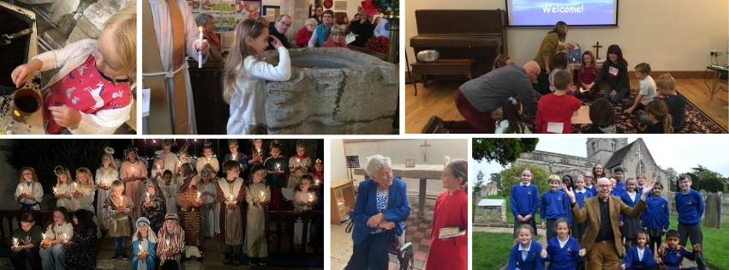
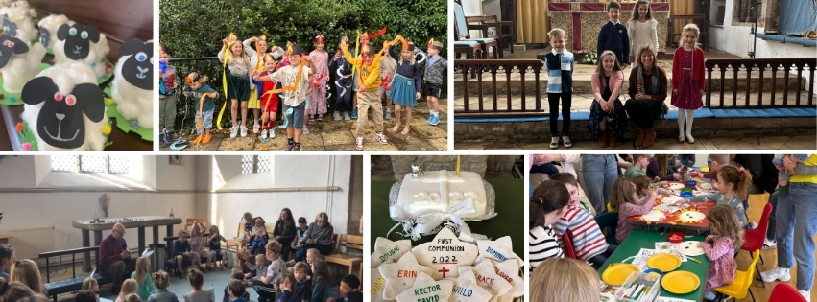

Our Groups
Church life in the Castor Benefice is lively and inclusive. Groups and events are often lay-led and provide opportunities for faith, fellowship, and fun — drawing in those within and beyond regular congregations.

Music and Choirs
Our multi-generational choir and children’s choir are key parts of worship at St Kyneburgha’s, Castor. They sing at Sunday services, festivals, and civic events and are supported by dedicated volunteers. Choir members range from school-age children to older adults, creating a strong sense of community through music.

Bell Ringing
We have an enthusiastic group of bell ringers who ring at services and events, with regular practices in Castor. Bell ringing is a valued tradition that helps signal worship and celebration throughout the benefice.

Festivals, Events, and Fundraising
The benefice hosts a wide range of events that bring our villages together, often raising funds for church and community causes:
- The St Kyneburgha Festival, held in July, features music, stalls, refreshments, and themed exhibitions — drawing large numbers from the village and surrounding areas.
- The Water Newton Music Festival is a highly successful summer event with live performances, food, and a joyful atmosphere in the historic setting of St Remigius’ churchyard.
- We hold fetes, garden parties, quiz nights, barn dances, concerts, and talks, often organised in partnership with local groups and supported by church volunteers.
- Craft fairs and seasonal fundraising events are popular and well-attended.
These events are an important part of our mission and outreach — they bring people together, showcase our heritage, and express our faith in action.

900 Years of Worship: Celebrating 2024
In 2024, St Kyneburgha’s Church celebrated 900 years of continuous worship, with a series of unforgettable events uniting the congregation and wider community:
- Festival Eucharist, celebrated with the Bishop
- A specially commissioned comic operetta, “The Legend of the Flowers and Brigands”, performed in the round at the church by local adults and children, accompanied by an orchestra and chorus
- Heritage exhibitions showcasing the architecture and history of the church
- A vibrant flower festival, crafted by community volunteers
- Concerts, talks, and school-led events highlighting the church’s legacy
- Creation and display of a community textile piece, “Work of Many Hands”, celebrating continuity and unity
The bellringers marked key moments with celebratory peals, bookending a weekend of worship, celebration, and outreach. The events drew large crowds and reflected both our deep roots and our shared hope for the future.

Pastoral and Social Support
Our Good Neighbours Scheme provides practical and emotional support to those in need — especially the elderly, bereaved, or isolated. Volunteers offer lifts to appointments, help with shopping, and friendly visits. This quiet but essential ministry is deeply appreciated and reflects our commitment to loving service.

The St Kyneburgha Buildings Preservation Trust
This charitable trust supports the conservation and development of St Kyneburgha’s Church, helping to fund maintenance and enhance the building’s community use. It plays a key role in enabling improvements and securing external support for major works.

A Spirit of Hospitality and Welcome
From the flower team and gardeners to service volunteers and refreshment hosts, our lay people are at the heart of church life. Across all parishes, people give generously of their time, skills, and spirit — keeping the churches open, cared for, and welcoming.
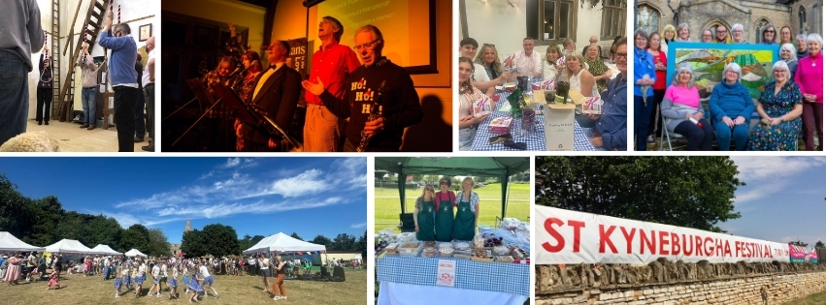
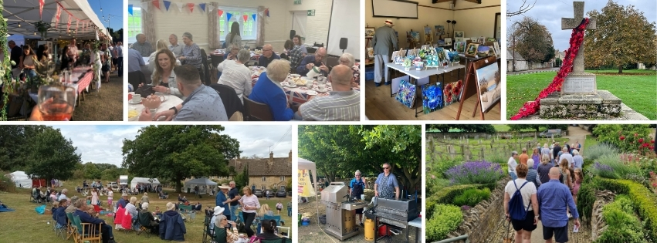

Our Team
Our benefice has benefited from a strong, team-based approach to ministry. While we are currently in vacancy, worship and mission continue with the support of a committed group of ordained and lay leaders.

Clergy
- Reverend Raymond Hemingray – Assistant Priest and former Diocesan Registrar, providing experienced leadership and pastoral care

Children’s Worker
- Helen Boulton – Voluntary Children’s worker, leading initiatives and worship for children and families

Lay Participation
We are supported by a wide range of lay volunteers who contribute to worship, pastoral care, outreach, and church life. This includes intercessors, readers, communion assistants, flower arrangers, sidespeople, and many others whose service is vital to the life of our churches.

Churchwardens and Volunteers
Each parish has one or more active Churchwardens, who work closely with the ministry team and PCCs to ensure the smooth running of services, maintenance of church buildings, and local engagement.

PCC and Committees
The Parochial Church Council (PCC) meets bi-monthly and provides strategic oversight for the benefice. It is supported by a number of dedicated committees, including:
- Standing committee – monthly review of issues
- Finance Committee – supporting budgeting and stewardship
- Income Generation Group – developing regular giving plans and fundraising
- Worship and Mission Committee – helping to shape liturgy, outreach, and service planning
- Children and Young People Committee – coordinating ministry for younger members and families
This structure allows for broad participation, shared leadership, and continuity across our six churches.

Administrator and Verger
The benefice is supported by a part-time Administrator, Jo Morris, who helps coordinate communication, service planning, and administration across the parishes. We are also fortunate to have a part-time Verger, David Edwards, who assists with the preparation and management of services and church events. It is anticipated that, subject to approval by the new Rector, both roles would continue going forward.

Safeguarding
We take our safeguarding responsibilities seriously and are committed to maintaining a safe environment for all. Safeguarding is embedded in our governance structures and regularly reviewed by the PCC. Our dedicated and experienced Parish Safeguarding Officers are:
- Christine Murrell
- Anne Perkins
They work closely with the PCC and clergy team to ensure compliance with diocesan and national safeguarding policy, and to support training and good practice across the benefice.

Our Finances
Following COVID, and like many Church of England churches, the Castor Benefice has had to deal with a challenging financial situation over the last few years. Despite this background the Benefice has stable financial foundations, underpinned by careful management and the dedicated efforts of parishioners. The Benefice is committed to meeting its financial obligations, including the full payment of the Parish Share each year. Given the goodwill and enthusiasm in our community we believe there is a real opportunity to further improve the finances of the Benefice to allow us to further our Ministry.
In 2024, after payment of the Parish Share in full, the Castor P.C.C. reported a small loss of (£1,006). Donations (regular giving and collections) and legacies raised £90,973 in the year, and fundraising raised £18,180. Fundraising was down on expectations mainly due to the focus on the 900th St. Kyneburgha Anniversary Celebration events help through the year. In the year ahead more focus is being brought back onto both regular giving and fundraising.
The Finance Committee, in collaboration with the Income Generation Committee and the broader P.C.C., closely monitors budgets and ensures financial stewardship across the Benefice. Several initiatives are under development to further secure our financial base.
In addition to regular giving, the Benefice benefits from:
- Gift Aid and tax reclaim contributions
- Events and lettings income from facilities such as the Cedar Centre
- Support from The St Kyneburgha Building Preservation Trust, which helps fund essential building works
- Income from regular fundraising events
We remain committed to sustaining the mission and ministry of the church while maintaining our beautiful heritage buildings. Ongoing fundraising and generous giving will continue to be crucial to achieving this.
Castor P.C.C. 2024 Financial Summary

Category | Amount
Total Income (including all voluntary income, trading, service fees) | £161,115
Total Expenditure (including fees, fundraising costs, Parish Share) | £162,121
Net | (£1,006)
Donations (regular giving, collections) | £70,973
Legacies | £20,000
Fundraising Net Income | £18,180
Parish Share Paid | £59,016

Our Organisation
The Castor Benefice operates with a clear and collaborative structure to support worship, mission, pastoral care, and stewardship. The benefice is led by the Incumbent and supported by both ordained and lay leadership, as well as a committed network of volunteers.

Parochial Church Councils (PCCs)
The benefice comprises three parishes with their own governance:
- Castor with Upton, Stibbington, and Water Newton is served by the main Castor PCC, which meets bi-monthly and provides strategic oversight for worship, mission, finance, and buildings across the parish.
- Marholm and Sutton each have their own PCC, which oversee the life, ministry, and governance of their respective churches. These PCCs work in collaboration with the clergy and wider benefice team, while retaining responsibility for their own parish matters.
The Castor PCC is supported by the following committees:
- Standing Committee – monthly review of issues
- Finance Committee – overseeing financial planning, budgeting, and stewardship
- Income generation group – increasing regular giving and planned fundraising events
- Worship Planning group – planning for all services
This structure allows each parish to retain its distinct identity and voice, while enabling joint working where appropriate.

Patronage
The joint patrons of the benefice are:
- Sir Philip Naylor-Leyland
- Mrs Verity Gunnery
- Keble College, Oxford
We value the continued interest and support of our patrons in the life of the benefice.

Day-to-Day Administration
The benefice is supported by a part-time Administrator, Jo Morris, who coordinates communication, diary management, and service preparation. A part-time Verger, David Edwards, assists with service logistics and care of the churches.
The Benefice Office, located in the Cedar Centre next to the church in Castor, acts as a hub for administration, meetings, and ministry support.

Safeguarding and Governance
We are committed to maintaining a safe and welcoming environment. Safeguarding is embedded in our governance, with two Parish Safeguarding Officers — Christine Murrell and Anne Perkins — working alongside the PCC to uphold diocesan policy and good practice.
The St Kyneburgha Building Preservation Trust
The St Kyneburgha Building Preservation Trust, while independent, plays a vital role in maintaining the fabric of our historic buildings. It supports major repairs and restoration projects and is an important partner in sustaining the long-term future of our churches.

Our New Rector
We are looking for a new Rector who will inspire, guide and grow with us as we move into the next chapter of our shared journey.
There is much to celebrate in our benefice — and much still to be done. We hope our new Rector will bring fresh energy, spiritual depth, and a shared commitment to growing our worship, welcome, and witness.

Role Description

Worship and Spiritual Life
- Lead regular Eucharistic and non-Eucharistic worship across the benefice in our inclusive Liberal Catholic tradition
- Nurture and develop the spiritual life of each church and congregation
- Support lay leadership and a strong team approach to ministry
- Encourage the musical and liturgical life of the churches, including choirs and bell ringers

Children, Families and Schools
- Support and grow Children’s Church, SKY, and family services
- Take an active role in Castor CE Primary School — as priest, friend, and governor
- Welcome and nurture families, young people, and children into church life

Pastoral Care and Community Engagement
- Be visible and approachable in all villages
- Provide pastoral support to the sick, bereaved, elderly and isolated
- Engage with village life and local groups — from festivals to fundraising

Leadership and Governance
- Work collaboratively with clergy, lay leaders, and volunteers
- Chair and guide the work of three PCCs and their subcommittees
- Empower others in ministry, administration, and mission
- Ensure effective safeguarding and good governance practices

Buildings and Heritage
- Value and support the maintenance of five listed church buildings
- Collaborate with the St Kyneburgha Building Preservation Trust and others
- Embrace the use of church buildings for worship, community, and cultural events

Person Specification

Essential Qualities
- A prayerful and Eucharistically rooted priest
- Committed to inclusive, compassionate, and mission-focused ministry
- Confident in leading worship and preaching
- Able to communicate warmly with people of all ages
- Actively supports ministry with children, families, and young people
- Organised, adaptable, and capable of managing multi-parish responsibilities
- Experienced in collaborative leadership and empowering others
- Approachable and pastorally sensitive
- Willing to be actively involved in school life and village communities
- Respectful of tradition, while open to growth and innovation

Desirable Qualities
- Experience in the care or oversight of historic buildings
- Supportive of music in worship, including choirs and bell ringers
- Familiar with rural and village contexts
- Knowledge of PCC governance, safeguarding and parish operations
- A good sense of humour and personal resilience
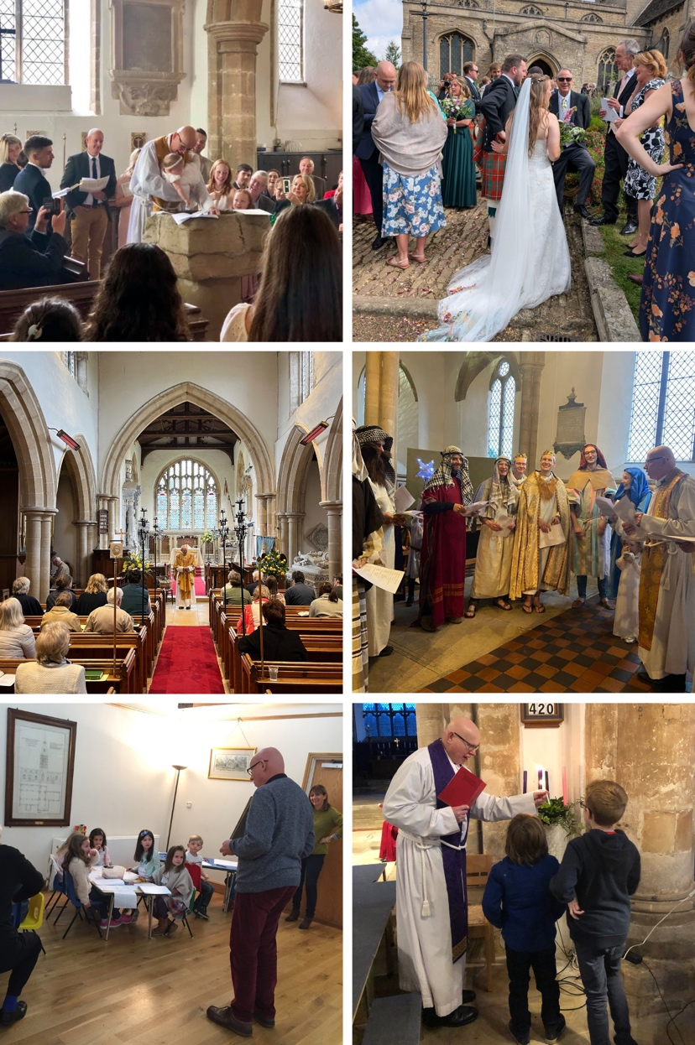

A place to call Home
Welcome to the Rectory — a spacious and well-presented four-bedroom detached home located in the heart of Castor, one of the most desirable and well-connected villages west of Peterborough.
Set on a generous private plot, the Rectory combines practicality, comfort, and peace — offering the perfect base for family life and ministry in the benefice.

Key features include:
- A bright and welcoming entrance hall
- A dedicated study — ideal for parish work or home working
- A spacious dual-aspect living room
- A separate dining room and a good-sized, modern kitchen
- Four bedrooms upstairs, including a principal bedroom with ensuite
- A family bathroom and a ground floor cloakroom/WC
- Single garage and off-street parking
- A large, enclosed garden with lawn — perfect for gatherings or quiet reflection

Location highlights:
- Less than 5 minutes’ walk from St Kyneburgha’s Church, the Cedar Centre, and Castor CE Primary School
- Easy walking access to the village shop, pub, and GP surgery
- Excellent transport links to Peterborough (rail: London in under 50 mins) and the A1
This is a home that has supported both ministry and family life with warmth, privacy, and space — offering the incoming Rector a true sanctuary at the heart of our village.

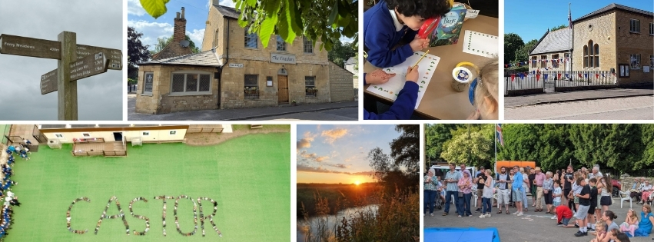

A position for you?
Is God calling you?
We hope this profile has given you a clear and inspiring picture of our benefice — its churches, its people, and our shared life of worship and service. We are excited about the future and prayerfully discerning the person God is calling to lead us in the next stage of our journey.
You will be joining a supportive and spiritually rooted benefice with a strong sense of identity and purpose. We value our traditions, but we are open to new ideas. We are committed to children, young people and families, to inclusive worship, and to being a visible, caring presence in our communities.
We know the role of a parish priest is both joyful and demanding — and we will walk with you in prayer, practical support, and partnership.
If you feel called to this role, we would love to hear from you.

To find out more:
- Parish website: www.castorchurch.co.uk
- A Church Near You (Castor): www.achurchnearyou.com/church/10010
- St Kyneburgha Building Preservation Trust: www.castorchurchtrust.co.uk
- Castor CE Primary School: www.castorschool.com

Informal contact can be made with The Rural Dean The Revd Jackie Bullen
Tel: 01733 263016
Email: jacqbullen@aol.com

Or

The Archdeacon of Oakham The Venerable Alison Booker:
Email: archdeacon.Oakham@peterborough-diocese.org.uk

Archdeacons Office:
Cheryl Cullen (PA)
Tel: 01733 887019
Email: pa.archdeacons@peterborough-diocese.org.uk

An application form can be obtained from the Diocesan website, vacancies section,
www.peterborough-diocese.org.uk/vacancies2

