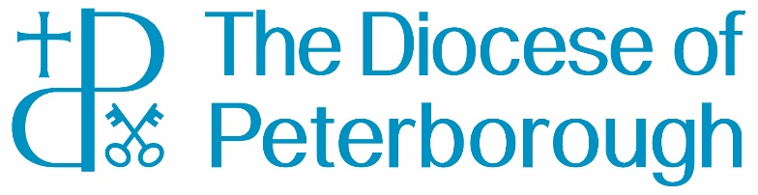

The Peterborough Diocesan Board of Education

Privacy Policy

Introduction
The Peterborough Diocesan Board of Education has a duty to support Church Schools in the Peterborough Diocese, a duty laid out in the Diocesan Boards of Education Measure.
In order to carry out these duties the DBE processes personal data in accordance with the UK GDPR 2018. The Diocesan Board of Finance (DBF) is the data controller for all personal data held, and the overarching privacy notice for the DBF can be found here Data Protection and Privacy - The Diocese of Peterborough (peterborough-diocese.org.uk)
This privacy notice applies to personal data collected to fulfil the DBE legal obligation to provide pastoral care to Church School officers and staff in this Diocese.

What is the legal basis for processing your personal data?
This processing is necessary for compliance with a legal obligation. For example, our obligations under the DBE Measure
We are highly unlikely to process special category data in any of the work we do. However, if this is necessary we will do so under the Article 9 condition ‘not for profit bodies’. Under this condition we will only share your data with third parties with your consent. To do this we will ask and record your specific ‘consent’ before we collect and process your personal data, in the event we need to do this a copy of the record template will be found on our website.

How long do we keep your personal data?
We keep data in accordance with the guidance set out in the guide “Save or Delete: The Care of Diocesan Records”, which is available from the Church of England website: https://www.churchofengland.org/more/libraries-and-archives/records-management-guides.

Complaints
If you believe that the Diocesan Board of Education has not complied with your data protection rights, please contact our Data Protection Officer (contact details below). You also have the right to complain to the Information Commissioner’s Office (‘ICO’) at any time. The ICO is the UK supervisory authority for data protection issues and contact details can be found on the ICO website – www.ico.org.uk.

Changes to this Privacy Notice
The PDBF reserves the right to update or amend this Privacy Notice at any time. We keep this Privacy Notice under regular review and we will place any updates on this web page – https://www.peterborough-diocese.org.uk/changes-in-data-protection-/data-protection.

How to contact us
If you have any questions about this Privacy Notice or how we handle your personal information, please contact our Data Protection Officer, Susan Ratcliffe, through one of the following ways:
Mail: The Peterborough Diocesan Board of Finance, The Palace, Peterborough, PE1 1BA
Telephone: 01733 887039
Email: sue.ratcliffe@peterborough-diocese.org.uk

