# 

Welcome to the first newsletter of this summer term!

THANK YOU!

Thank you for your dedication and commitment throughout the last two years of the pandemic. The Diocesan Board of Education joins me in sending their heartfelt thanks to you and all your staff.  We are very grateful to you all, for everything you have done and continue to do for the school communities you serve, in providing education for life, which is deeply Christian and serves the common good.

EASTER BLESSINGS

Christians are, in every season, an Easter people. Easter reminds us that following in the footsteps of Christ brings such tremendous blessings – forgiveness for the past, abundant life for the present and hope for the future. I trust that you have had a good Easter holiday and are looking forward to the term ahead, and pray that you will know God’s ‘goodness and love following you all your days’ (Psalm 23: v8).

SUMMER TERM HEADTEACHERS’ CONFERENCE – HAPPINESS, WELLBEING, RESILIENCE, GROWING AND FLOURISHING

This term’s Headteachers’ Conference will be on Thursday 16th June and the programme is as follows:

*9.15 – 9.45am Worship – Reflections on ‘Happiness, Wellbeing, Resilience, Growing and Flourishing’*

*9.45 – 10.30am & 10.45 – 11.30am Wellbeing and Resilience*

Dr Bill Mitchell, a highly experienced clinical psychologist, whose clinical work is about rebuilding resilience in people who have been temporarily ‘de-railed’ by complex life events, and whose recent keynote address to a Church of England headteachers’ conference in the Diocese of London was extremely well received, will address the theme of ‘wellbeing and resilience’, encompassing:

* identifying personal pressures
* recognising early signs of not coping
* the physiology of mental fitness
* having helpful conversations.

*11.30am – 12.15pm Good Childhood*

Richard Crellin will speak about the Children’s Society ‘Good Childhood’ report, which is a vital tool for measuring the happiness and well-being of children and young people; it is the only report of its kind that actually asks the questions directly to children and young people, rather than to their parents and carers, and which has been used to inform government policy.

*12.15 – 12.30pm Specialist Psycho-Therapeutic Services for Children and Young People*

Emma Connor and Suzanne Ryan, Directors of Your Space Therapies, will outline examples of specialist, high quality therapy that are available for children, young people and whole school communities.

*1.00 – 1.45pm Supporting Vulnerable Children and Families*

Ian Soars will share with us the support that Fegans (a leading UK charity supporting vulnerable children and families) is able to offer and why it is so important.

*2.00 – 3.00pm Experiencing A Greater Personal Sense of Peace, Wellbeing and Community*

Chris Whittington will lead an experiential workshop; you will be introduced to meditation in the Christian tradition, as a simple but radically effective path to greater peace, wellbeing and community. Through a series of short talks and periods of practice, we’ll explore:

* forming a new relationship with life with all that offers us and throws at us
* establishing peace in ourselves so we can be places of peace for those around us
* taking what we have encountered out into our daily life and places of work.

All bookings can be made via [education@peterborough-diocese.org.uk](mailto:education@peterborough-diocese.org.uk).

RE NEWSLETTER

Our RE & Collective Worship Adviser, Lesley Pollard, has put together a fantastic summer term

newsletter, bursting with ideas, resources, courses, reports and examples of great practice. A copy is attached, which has also been shared with RE Subject Leaders across the Diocese.

EMMANUEL PROJECT

Jane Sheat, Director of Education for the Diocese of St Edmundsbury & Ipswich, has been in touch to share details about the Emmanuel Project, an RE scheme of work for primary schools, covering Christianity and other world faiths, and which complements the Understanding Christianity course in RE. For more information and sample units, please see: <https://www.cofesuffolk.org/schools/school-leaders/religious-education/emmanuelproject/>.

SCHOOL SIAMS PERFORMANCE DATA

We have received an insightful report on school SIAMS performance nationally, further underscoring the increased level for challenge in Church of England schools achieving excellence within the most recently revised SIAMS schedule. A copy is attached for you. We are delighted that 100% of our schools in Peterborough Diocese have achieved ‘good’ or ‘excellent’ outcomes under the new SIAMS inspection schedule, and we look forward to continuing to work closely with all our Gold SLA schools to ensure that together we provide the best possible education for all the children and young people in our care.

DBE EDUCATION TEAM TRAINING COURSES THIS HALF-TERM

There are a number of DBE training events on offer this half-term, including:

*Developing Children’s Spirituality Tuesday 26 April 2022 10.00am – 3.00pm led by Jane Lewis, via Zoom*

What does it mean to experience life in all its fullness?  We will explore some answers and consider how Ofsted and SIAMS evaluate spiritual development.

*Understanding Christianity:  Focus on Salvation Tuesday 10 May 9.00am – 12.00pm led by Adam Robertson, via Zoom*

This session will focus in greater depth on the theme of Salvation using Understanding Christianity. Adam helped to write the Diocese of Peterborough RE Syllabus.

*Roles & Responsibilities of Church School Governors Wednesday 12 May 6.30pm - 8.30pm led by Peter French, at Bouverie Court*

What are the special features of church school governance?  A session for new governors and those who have previously been governors looking at experiences and how you can develop your role.

*RE: Assessment / Ofsted Research Monday 16 May 1.00pm – 4.00pm led by Lat Blaylock, via Zoom*

How can school RE use the directions set by HIM’s RE report?

*Implementing the Understanding Christianity Resource Tuesday 17 May 9.30am – 3.30pm led by Lesley Pollard at Hayfield Cross CE Primary School, Kettering*

Specifically for primary teachers who are new to using the Understanding Christianity resource, but whose school is already trained in this programme.

*Termly Headteachers’ SIAMS Briefing Thursday 26 May 1.30pm – 3.00pm led by Jane Lewis, via Zoom*

Updates and feedback on inspections so far; a workshop to look at different self-evaluation approaches and to ensure your school is well prepared.

*Governor Briefing Session:  Tips on Recruiting Governors Thursday 19 May 6.30pm – 7.15pm led by Peter French, via Zoom*

To book a place on any of the SLA courses, please email: [education@peterborough-diocese.org.uk](mailto:education@peterborough-diocese.org.uk).

SEPTEMBER CATHEDRAL SERVICE FOR ALL DIOCESAN SCHOOLS – 29TH SEPTEMBER, 2.00PM

Before the pandemic, we held an annual service of dedication and thanksgiving for all diocesan schools at Peterborough Cathedral every September.  We have now set the date for this year – Thursday 29th September.  Primary schools are welcome to bring a whole KS2 year group or two year groups if you have two year groups in one class, and secondary schools are welcome to bring the equivalent of about one class, whether that be all your student leaders, a cohort of Pupil Premium students or another group of your choosing.

There will be a combined primary school choir led by Jim Bonsor. Jim has kindly offered to visit primary schools in the summer term to coach and rehearse choirs that will be participating. There will also be a combined secondary school choir, encompassing students from diocesan schools in the maintained sector and independent sector. The music at previous services has been fabulous and we’d be very grateful to have the support of your choir. Please contact Alex in the office, via [education@peterborough-diocese.org.uk](mailto:education@peterborough-diocese.org.uk) if you would like your school choir to be involved and also to reserve places for children / young people from your school to attend.

GLOBAL NEIGHBOURS

Global Neighbours is the result of a partnership between The Church of England Education Office and Christian Aid, offering schools the opportunity to pursue the SIAMS theme of courageous advocacy in a well-crafted and purposeful way, making a positive difference to people’s lives in the developing world. Since its launch in April 2018, over 1100 schools have registered onto the scheme. If you would like to get involved, please contact Alison Brown, Global Neighbours Schools Programme Officer via 020 7523 2056 / [abrown@christian-aid.org](mailto:abrown@christian-aid.org). This also presents a great opportunity for church schools and parish churches to work together on a common theme to benefit people through a shared charitable enterprise.

COORDINATING SUPPORT FOR UKRAINIAN REFUGEES

There was an excellent webinar last week, delivered by Dr Krish Kandiah and the Sanctuary Foundation, about how to provide support for Ukrainian refuges most effectively: [Coordinating Community Support for Ukrainian Refugees - YouTube](https://www.youtube.com/watch?v=4ii6t9iRANQ). The webinar is still available to view and is well worth watching.

PADDINGTON THE REFUGEE



In the late 1930s -1940s, Michael Bond, author of Paddington Bear, saw Jewish refugee children (Kindertransport children) passing through Reading Station from London, arriving in Britain escaping from the Nazi horrors of Europe.  Mr Bond, touched by what he saw, recalled those memories 20 years later when he began his story of Paddington Bear. One morning in 1958, he was searching for writing inspiration and simply wrote the words: “Mr and Mrs Brown first met Paddington on a railway platform…”

“They all had a label round their neck with their name and address on and a little case or package containing all their treasured possessions,” Bond said in an interview with The Telegraph before his death in 2017. “So Paddington, in a sense, was a refugee, and I do think that there’s no sadder sight than refugees.”

Paddington Bear is known for his blue overcoat, bright red hat, and wearing a simple hand-written tag that says: “Please look after this bear. Thank you.” Paddington embodies the appearance of many refugee children. His suitcase is an emblem of his own refugee status.

“We took in some Jewish children who often sat in front of the fire every evening, quietly crying because they had no idea what had happened to their parents, and neither did we at the time. It’s the reason why Paddington arrived with the label around his neck” - Michael Bond

Michael Bond died at 91 in 2017. The epitaph on his grave reads, "Please look after this bear. Thank you."

THE ARCHBISHOP OF YORK YOUTH TRUST - YOUNG LEADERS AWARD WEBINARS AND PLATINUM JUBILEE CHALLENGE

If you’re looking for a programme that supports pupils in developing leadership and character through social action, come and find out more about the Young Leaders Award Programme through ABYYT’s free online sessions this term for both primary and secondary schools. They are also running Introduction to Character Education sessions with input from Dr Tom Harrison at the Jubilee Centre for Character and Virtues. To find out more and sign up: [www.abyyt.com/events](http://www.abyyt.com/events). Moreover, ABYYT’s ‘Platinum Jubilee Challenge’ asks pupils to consider what they would like to see change for the better over the next 70 years and to think about how they can start to take action towards these changes now and ‘be the change they want to see’ in their communities. To take part head to the ABYYT website [www.abyyt.com/jubilee](http://www.abyyt.com/jubilee)  where you can download a free activity pack.

OFSTED & SIAMS SUCCESSES

Many congratulations to St Loys, WSSES, Eye, Great Casterton, Blakesley, Pattishall, Tiffield and Towcester on successful Ofsted and SIAMS inspection reports last term.

SCHOOL VISITS

It was a pleasure to visit Pattishall, Brixworth, St Mary & St John, Finedon Muso, Harpole, Geddington, Brackley, St Peter’s, Croughton, MAPS, Clipston, All Saints Northampton, Wilbarston, Ashton, Weston Favell and Newbottle & Charlton last term. Thank you for the warmth of your welcome. Archdeacon Richard and I are also continuing to Zoom with Headteachers and Chairs of Governors, and I look forward to visiting more of our schools in person during this summer term.

NATIONAL ACADEMY AND SCHOOL NEWS

Attached are the latest academy and school news updates from educational consultant Tony Stephens.

JOINING A MULTI-ACADEMY TRUST

58 of our 103 schools belong to one of our 9 multi-academy trusts. As a Diocesan Board of Education, we are involved in the governance of all these MATs, as Members and Directors, as well as in supporting the governance of 5 standalone academies and 40 VA / VC schools, and serve on the education committees and forums of our LAs. We are always happy to provide advice in relation to joining a MAT; we would give a presentation and then open up the matter for discussion and questions from governors. If you would like to book such a presentation simply email Alex Benoy at: [education@peterborough-diocese.org.uk](mailto:education@peterborough-diocese.org.uk).

COMEDIAN FRANK SKINNER ON ATHEISM

I came across this quote from the comedian Frank Skinner over Easter and thought you would enjoy it…

*‘I have friends who are atheists. There’s this mate of mine. He says, ‘It’s such rubbish. Come back to my flat and I’ll make a cup of tea and we’ll talk the whole thing through.’*

*So I go back with him and he puts the kettle on. ‘The thing is, Frank, the universe – it just happened. A big bang, an accident, no one made it happen. There’s no great designer, no thought went into it or planning, it just happened – do you get it? … Anyway, that cup of tea won’t make itself.’*

*I said, ‘Why not?’*

DIOCESAN SCHOOLS CONSULTANTS

We are blessed with a great team of Diocesan Schools Consultants; serving headteachers and experienced former headteachers. We are looking to recruit one or two more DSCs for 2022-2023. We would welcome applications by Friday 20th May. Interviews will be held in June. Further details are available on request from [education@peterborough-diocese.org.uk](mailto:education@peterborough-diocese.org.uk).

HERE FOR YOU

You are welcome to get in touch with any member of the Diocesan Education Team at any time, our email addresses are below:

Director - [peter.cantley@peterborough-diocese.org.uk](mailto:peter.cantley@peterborough-diocese.org.uk)

Deputy Director - [peter.french@peterborough-diocese.org.uk](mailto:peter.french@peterborough-diocese.org.uk)

Assistant Director - [jane.lewis@peterborough-diocese.org.uk](mailto:jane.lewis@peterborough-diocese.org.uk)

Schools Effectiveness Adviser - [andrew.lakatos@peterborough-diocese.org.uk](mailto:andrew.lakatos@peterborough-diocese.org.uk)

Religious Education & Collective Worship Adviser - [lesley.pollard@peterborough-diocese.org.uk](mailto:lesley.pollard@peterborough-diocese.org.uk)

Executive Administrator - [alex.benoy@peterborough-diocese.org.uk](mailto:alex.benoy@peterborough-diocese.org.uk)

Administrator - [louise.ross@peterborough-diocese.org.uk](mailto:louise.ross@peterborough-diocese.org.uk)

Finance Officer - [mark.bedford@peterborough-diocese.org.uk](mailto:mark.bedford@peterborough-diocese.org.uk).

GREAT LEADERSHIP

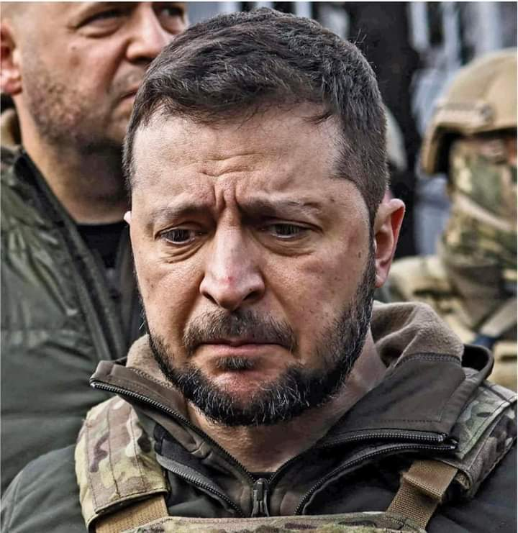

Reflecting on this photo of President Volodymyr Zelensky and the conflict in Ukraine, Pete Greig, best-selling author, pastor and instigator of the 24/7 prayer movement, has suggested there are six marks of great leadership we should all aim to emulate:

*‘1. Great leaders care. They are empathetic, emotionally engaged. They are not in it for themselves.*

*2. Great leaders are courageous. They do not shy away from sacrifice or run away from conflict. They lead by example, from the front.*

*3. Great leaders understand their brand. They are not chameleons. They do not try to please everyone. They are comfortable in their own skin, clear about the particularities, the power and the limitations of their own contribution.*

*4. Great leaders build great trust; they do not stand alone. They have others looking over their shoulders and covering their backs. They instinctively build team.*

*5. Great leaders are intensely focused. They work out what matters and shut out everything else (realising that ‘what matters’ is rarely the loudest or most urgent demand upon their time.)*

*6. Great leaders understand the power of symbolism. They leverage their own profile and presence to maximum effect. They capture the narrative long before they capture their ultimate prize.’*

PRAYER

If you have a particular matter which you would like to draw to our attention for prayer, in confidence, please don’t hesitate to get in touch; it would be our privilege to pray for you and your school. May I also share with you a prayer from the Church of England for peace in our world, in these days of the most appalling abuse of power and horrific war crimes…

*Almighty God,*

*from whom all thoughts of truth and peace proceed:*

*kindle in the hearts of all people the true love of peace;*

*and guide with your pure and peaceable wisdom*

*those who take counsel for the nations of the earth;*

*that in tranquillity your kingdom may go forward,*

*till the earth is filled with the knowledge of thy love;*

*through Jesus Christ our Lord. Amen.*

AND FINALLY – A BLESSING FOR YOU AND ALL THOSE NEAR AND DEAR TO YOU

*‘The Lord bless you and keep you; the Lord make his face shine on you and be gracious to you; the Lord turn his face towards you and give you peace.’* (Numbers 6:v24-26)

Wishing you every blessing now and always!

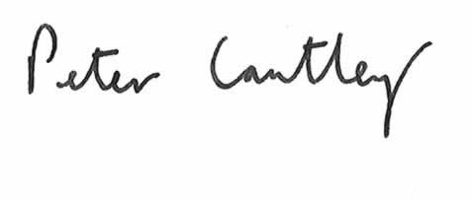

Peter Cantley

Diocesan Director of Education