Dear Colleagues

Please find registration details below for ExpertEd’s free webinars taking place this term for years 5-8.

The first, Family Science, is for pupils and families to join in the evening. Please find a letter attached and link which can be forwarded to parents.

The next 2 are Highlight Speaker events for classes of pupils during the school day.

ExpertEd offers schools and pupils the chance to learn through live interaction with experts in a variety of curriculum areas, providing enrichment and curriculum coverage.

What’s on | Free evening events for pupils and their families | When | Registration
  Family Science | Led by Dr Becky Lewis from Swansea University, Family Science aims to offer some stretch and challenge to pupils and to encourage conversations about science between inquisitive young people and their parents. Each session has a different guest, exploring a new area of science. The sessions are live, fun, and interactive. For years 5-8. | 4 Wednesdays starting 14th January 7pm | Parents Register here.  Letter attached to give to parents.

What’s on | Events for Schools | When | Registration
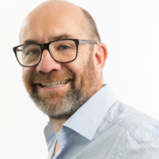Highlight Speaker: The Rt Hon Lord Knight of Weymouth. | Inspire your class to think about Parliament, citizenship, and their role in shaping the future by meeting current member of the House of Lords, The Rt Hon Lord Knight of Weymouth. Discover how Britain’s laws are shaped and how the Lords work in our democracy in a fun and interactive webinar. This session gives pupils the chance to ask their own questions to Lord Knight. For Years 5-8. | Monday 26th January 2pm (30mins) | Teachers Register here.
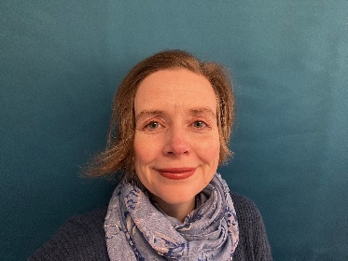Highlight Speaker: Helen Cuthill | Join us for an inspiring webinar with Helen Cuthill from The Smallpeice Trust. Helen will share her story of growing up with dyslexia and how she faced challenges with confidence, resilience and determination. We’ll hear how her experiences helped shape her journey into a successful career, leading to her current role as CEO of The Smallpeice Trust, a charity that helps pupils fuel their passion in STEM and engineering. For Years 5–8. | Monday 9th Feb 2pm (30min) | Teachers register here.

For more details see our website. Please email us if you wish to be removed from the mailing list.

Best wishes,

Kirsty

 | Kirsty Burns  ExpertEd Administrator  Great Hall, New Street, Oundle, Peterborough PE8 4GH  www.oundleschool.org.uk

