And they were great!

God made frogs!

Frog facts:

1. A group of frogs is called an army
2. Frogs are amphibians therefore cold-blooded. This means that their body temperature matches the temperature of the air around them.
3. Frogs hatch from frogspawn after 6-21 days, to begin life as tadpoles, then grow into juvenile froglets. Finally, they develop into adult frogs.
4. Tadpoles have no lungs, they have gills. They grow lungs before they mature into a frog.
5. Common frogs in the United Kingdom hibernate during winter when the temperature drops.
6. Frogs drink water through what’s known as a ‘drinking patch’, which is located on the underside of a frog’s belly and thighs that allows them to absorb water through their skin.
7. A frog’s eyes and nose are on the very top of their heads. This allows them to see and breathe while most of their body is underwater. Frogs can breathe through the nose and their skin
8. The protruding eyes on the frog able them to see in front, to the sides, and slightly behind them.
9. They catch their prey with their tongue and use the eyes Their eyeballs assist them in swallowing food – they push the food down their throat by pushing down the eyeballs. So, frogs cannot keep their eyes open when eating
10. Some of the most common foods that frogs eat are bugs, spiders, worms, slugs, larvae, and sometimes small fish.
11. While frogs live both on land and in water, they move more efficiently on the ground by jumping and climbing. Using their long legs, many frogs can leap 20 times their body height!
12. Frogs may not sleep like humans but they do have periods of rest during which they tuck their limbs under their body, cover their eyes with their nictitating membrane and stay immobile for long periods of time.
13. Frogs have four fingers and five toes
14. Frog tracks look like this:



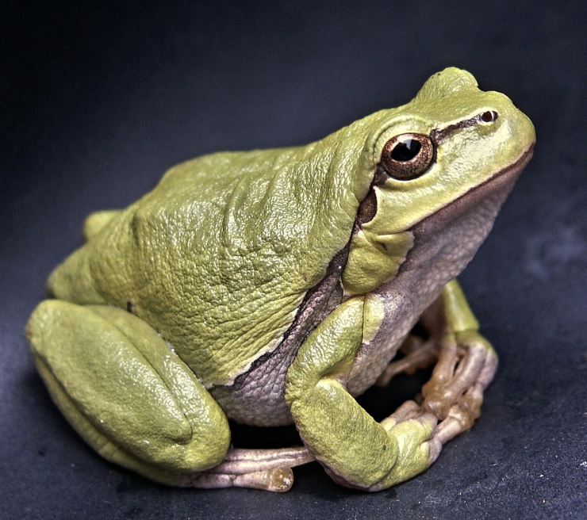

The frog