Join us in prayer this Easter season

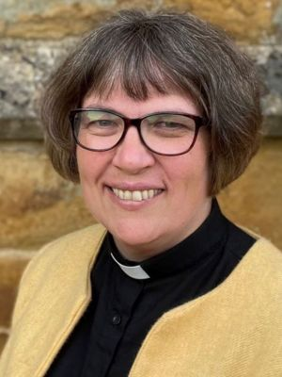
Easter Season, 50 days of celebration, a time for us as a Church to joyfully celebrate the love of God shown to us in Jesus whose death and resurrection open the way for us to know the God who loves us.
In the last 10 days of this season of celebration, between Ascension (Thurs 9th May) and Pentecost (Sun 19th May) there is the opportunity to join with others in prayer.
Thy Kingdom Come is an international prayer event, there are resources to help us pray, a Novena – which is a booklet of short readings and reflections, this year by Bishop Anthony Poggo (General Secretary of the Anglican Communion) and also a prayer journal which has beautiful artwork and video reflections drawing on different ways of praying.
In our own diocese we have 2 groups of people walking during this time the boundaries of the Diocese, with morning prayer each day which will be live streamed for anyone to join in with.
Whatever is helpful to you I encourage you to make use of this special time in the church year to try something new in prayer, or to spend some time praying in a way you are familiar and comfortable with, alone or with others, this is a time to pray together.

The Venerable Alison Booker
Archdeacon of Oakham

Diocese of Peterborough - Magazine Resource - May 2024
Produced by the Diocesan Office, The Palace, Peterborough, PE1 1YB
Tel: 01733 887000 Email: communications@peterborough-diocese.org.uk
www.peterborough-diocese.org.uk

