Farewell in Christ
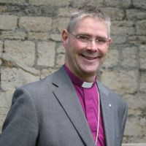
As fourteen years of ministry in the Diocese draw to a close, our overwhelming sense is of thankfulness. Elizabeth and I are so grateful to God for the privilege of my being called here to serve as one of your Bishops, the warmth of your welcome and the kindness of your support. We have been upheld by your prayers, humbled by your appreciation and thrilled by your willingness to serve Christ. It has been deeply moving to see God at work in our communities, churches and ministries. Thank you all so much.
Throughout my Christian life, I have been sustained by the bible verse printed on a bookmark that I attached to my bedside cupboard whilst growing up. It had God’s words of reassurance to Joshua as he took over leadership from Moses and read “Be not afraid, neither be thou dismayed, for I, the Lord thy God, will be with thee whithersoever thou goest” (Joshua 1.9).
I love the beautifully challenging prayer attributed to Sir Francis Drake;
Disturb us, Lord, when we are too well pleased with ourselves,
When our dreams have come true because we have dreamed too little,
When we arrived safely because we sailed too close to the shore.

Disturb us, Lord, when with the abundance of things we possess
We have lost our thirst for the waters of life;
Having fallen in love with life, We have ceased to dream of eternity
And in our efforts to build a new earth,
We have allowed our vision of the new Heaven to dim.

Disturb us, Lord, to dare more boldly,
To venture on wider seas where storms will show your mastery;
Where losing sight of land, we shall find the stars.

We ask You to push back the horizons of our hopes;
And to push into the future in strength, courage, hope, and love.

Please continue to pray for us as we will continue to pray for you, as the Diocese grows under Bishop Debbie’s inspiring leadership.
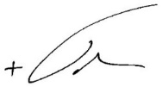
The Rt Revd John Holbrook
Bishop of Brixworth

Diocese of Peterborough - Magazine Resource – October 2025
Produced by the Diocesan Office, The Palace, Peterborough, PE1 1YB
Tel: 01733 887000 Email: communications@peterborough-diocese.org.uk
www.peterborough-diocese.org.uk

