Happy Easter

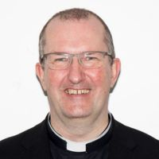
One Easter Sunday morning, as we reached ‘The Peace’ in our service, I said:

“Today, instead of saying ‘peace be with you’ we will try something different. Turn to someone and say, ‘The Lord is risen’ and they will reply, ‘He is risen indeed!’” Everyone nodded and smiled. So, I approached a tall man in the front row. “George, the Lord is risen!” I said with suitably uncontained enthusiasm. He replied, in a rather gruff and unimpressed voice, “I know.”

Perhaps on Easter Day, I should have stuck with the usual response: “Peace be with you.” Why? Because that is the way Jesus greeted his disciples after his resurrection. “Peace be with you.”

A friend of mine was once leading Collective Worship in his local primary school and asked the children what Jesus said to his disciples on that first Easter morning. A forest of hands went up. “Yes,” said my friend, pointing at an excited looking girl. “Happy Easter!” the girl replied. Well, not quite. “Peace be with you” was the answer he was looking for.

Before the world can experience a Happy Easter, there has to be a desire for that deep down, God-given peace. We watch the news on TV and there seems to be nothing we can do. Not true. We can start where we are – at work, at home or in the community.

Jesus said, “Blessed are the peacemakers for they will be called the children of God.”
Happy Easter!
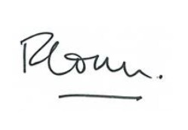
The Venerable Richard Ormston
Archdeacon of Northampton

Diocese of Peterborough - Magazine Resource – April 2026
Produced by the Diocesan Office, The Palace, Peterborough, PE1 1YB
Tel: 01733 887000 Email: communications@peterborough-diocese.org.uk
www.peterborough-diocese.org.uk

