A springtime for the soul

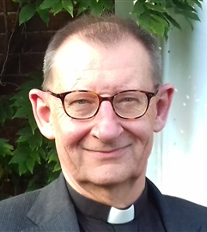
February can be a tough month. Christmas is long gone and meanwhile the winter drags on; the weather’s miserable and the news relentlessly depressing. There’s not much to celebrate it seems.
But there are some signs of things changing. In the woods, a scattering of brilliant yellow aconites hint at the sunshine that is to come and a bank of snowdrops defies the last frosts of the year. Nature is on the move.
And so too is God. As we enter the season of Lent, we tentatively begin our preparations for Easter. Ash Wednesday’s ceremonies may seem sober; reflecting on our mortality and need for forgiveness (“remember you are dust and to dust you shall return; turn away from sin”), but also pointing us to the One in whom all our hopes are founded (“be faithful to Christ”).
Traditionally a season of fasting, perhaps it might be better to think of Lent rather as a time to make space for God. Fast by all means but maybe it’s head space we really need, so why not, for example, turn our smart phones off for a few hours so we can think and feel and ‘be’ ourselves in the presence of God rather than at the beck and call of others?
Perhaps that way we might truly make Lent, what Brother Roger of Taize called it: “a springtime for the soul” and arrive at Easter with a renewed clarity about God’s love and care for us all.
Have a spacious Lent
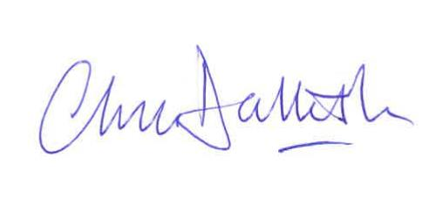
The Very Revd Chris Dalliston
Dean of Peterborough

Diocese of Peterborough - Magazine Resource - February 2026
Produced by the Diocesan Office, The Palace, Peterborough, PE1 1YB
Tel: 01733 887000 Email: communications@peterborough-diocese.org.uk
www.peterborough-diocese.org.uk

