God is Love
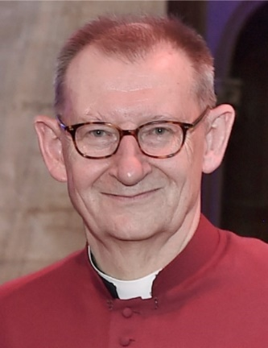
L
ent begins on the 14th February this year. That date might sound familiar to the more romantic among us; it is of course (Saint) Valentine’s Day and it might seem hard to hold together the two themes of human love and readying ourselves for a season of penitential preparation. Will it be hearts or ashes?
At one level, of course, the contradictions are less obvious. St John reminds us that: “God is love and those who live in love, live in God and God lives in them”. (1 John 16) He also says: “God so loved the world, that he gave his only Son so that everyone who believes in him may not perish but may have eternal life” (John 3:16).
Love is the meaning of it all – God creates the world in love, and in his love for the human race sends his Son to redeem fallen creation. Jesus comes to share our life, to live with us and die like us and for us but most importantly to rise again, so that we might know that love has the final word. And Jesus said that he came we might have life, life in all abundance, so I take all this to mean that the joy of loving human relationships is also very much his will. Romantic love can, perhaps, be an elusive quality; passion passes; but God’s love, as St Paul puts it in his great love poem in 1 Corinthians 13, that love never ends.
And it is God’s love and grace that our new Bishop will encourage us to share through our churches and in our communities in the months and years to come. Bishop Debbie’s much anticipated arrival is something in which we, at the Cathedral, have a very special part to play and it’s all systems go as we prepare for the 3rd March when we look forward welcoming people, parishes, institutions and civic life from across the Diocese and beyond for her service of Welcome and Installation.
Whoever said February was a dull month?!
Every blessing
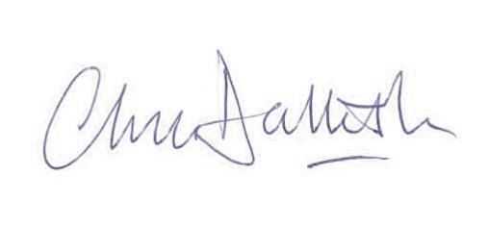

Chris Dalliston
Dean of Peterborough

Diocese of Peterborough - Magazine Resource - February 2024
Produced by the Diocesan Office, The Palace, Peterborough, PE1 1YB
Tel: 01733 887000 Email: communications@peterborough-diocese.org.uk
www.peterborough-diocese.org.uk

