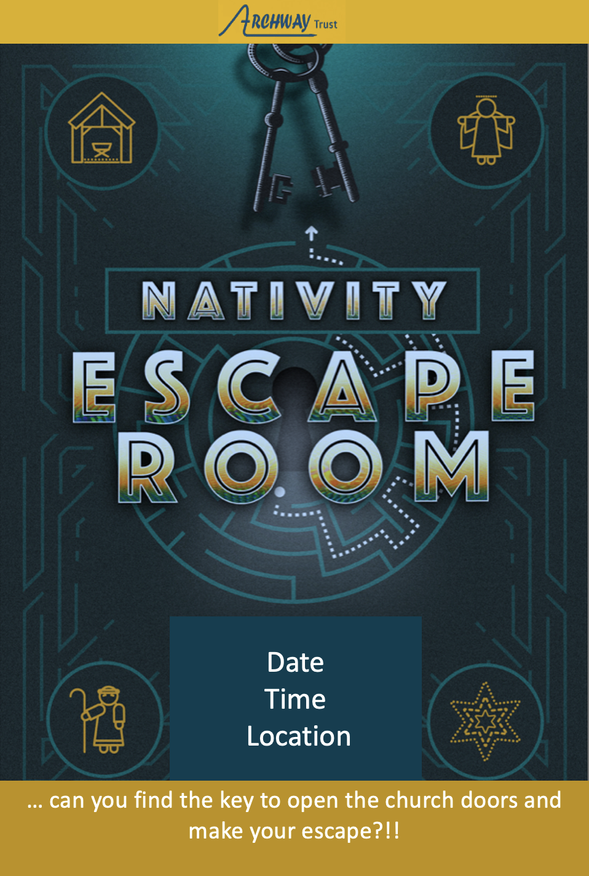

There are 44 prophesies in the Old Testament that match up with the birth and life of Jesus, who was born HUNDREDS OF YEARS LATER. Those who made these prophecies include Moses, Micah, Isaiah, King David, Hosea, Jeremiah, Zechariah and Malachi.

For example:
Around 700BC, the prophet Micah said that the Messiah would be born in
_ _ _ _ _ _ _ _ _
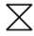

Around 725BC, the prophet Hosea said that the Messiah would come out of
_ _ _ _ _ which is where Mary and Joseph went, to escape from Herod!

Around 750BC the prophet Isaiah said that the Messiah would be born of a virgin _ _ _ _ _

The lives of these prophets were spread out over hundreds of years, and only a couple of these people even met each other. So how did they know all this precise and correct information?
Numbers 12 v 6 gives us the answer … can you work out what it is?
_ _ _ _ _ _ _ _ _ _ _ _ _ _ _ _ _

_ _ _ _ _ _

HOW DID THE PARENTS FIND OUT?

Take yourself back to Nazareth, a working-class town in Galilee. Nazareth is dusty, dingy and full of people working really hard for little money. The government recently increased people’s taxes, so no-one is smiling (not much has changed, has it?!) There is an older teenage girl named Mary living there, who is engaged to Joseph a carpenter.

One day Mary an angel appears to Mary and says:

-.-- --- ..- / .-- .. .-.. .-.. / --. .. ...- . / -... .. .-. - .... / - --- / .- / ... --- -. /
.- -. -.. / -.-- --- ..- / .- .-. . / - --- /
-.-. .- .-.. .-.. / .... .. -- / .--- . ... ..- ...
_ _ _ / _ _ _ _ / _ _ _ _ / _ _ _ _ _ / _ _ / _ /
_ _ _ / _ _ _ / _ _ _ / _ _ _ / _ _ / _ _ _ _ /
_ _ _ / _ _ _ _ _

The angel also appears to Joseph in a dream and tells him to marry Mary and that she will have a son and that they should call him Jesus because he will:

... .- ...- . / .... .. ... / .--. . --- .--. .-.. . / ..-. .-. --- -- / - .... . .. .-. / ... .. -. ...
_ _ _ _ / _ _ _ / _ _ _ _ _ _ / _ _ _ _ / _ _ _ _ _ /
_ _ _ _

This is obviously not a normal baby!! Was your birth announced like this … with angels?!

Jesus is the Son of God. He could have been born in a palace to a royal family. Instead, He was born in another working-class town:
_ _ _ _ _ _ _ _ _

which was full of people, due to the census that required everyone to return to their ancestral home town. The town is heaving … and Mary is about to give birth to her baby! Uh oh! NOW WHAT?!!

There are no rooms available, so Mary gave birth in a
_ _ _ _ _ _ where the all the animals live!!!

She wrapped her new born baby and laid him in a
_ _ _ _ _ _ where the all the animals eat out of – a feeding trough!!

THIS WAS THE SON OF GOD BUT
_ _ / _ _ _ _ _ _ / _ _ / _ _

&

_ _ _ _ / _ _ _ _ / _ _ _ / & / _ _
The Magi (wise men) were considered special astronomers in the day of Jesus. They felt that the night sky displayed God’s artwork, but that the stars also acted like a language. If you could read that language, you could read an outline of God’s plans for mankind. They saw a very important star! Follow them across the cold desert and see where it leads...
They leave their home country which is where:
_ _ _ _ / _ _ _ _ are today
42 24 41 33 / 42 24 41 44
To find the new born baby king they go to the:
_ _ _ _ _ _ in the capital _ _ _ _ _ _ _ _ _
23 41 13 41 51 31 12 31 24 34 54 41 13 31 53
BUT HE ISN’T THERE!! Herod’s advisors look up the town where the prophet Micah said that Jesus was going to be born. (Micah 5 v 2) Micah said this around 700 years before it happened!!! So, the Magi follow the star again and find the baby … in the town exactly where Micah said He would be!! AMAZING EH?!!!
So why did the Magi trust the star to lead them to the new baby king?!! The prophet Isaiah who was around 750 years before Jesus, gives us a clue (Isaiah 40 v 26)
_ _ _ is the _ _ _ _ _ _ _ of every _ _ _ _
22 43 11 51 24 31 41 14 43 24 54 14 41 24
He brings them out one by one and calls each one by _ _ _ _
33 41 53 31

MYSTERY # 5:
WHO WERE THE FIRST PEOPLE TO FIND OUT ABOUT THE BABY?

Look around the area and find the missing words for each space. Please don’t go over the altar rail – there are no clues over there!

This part of the Christmas story can be found in Luke chapter 2.

The ___________ ___________ were _____________ in a _______ _______ when an _______ suddenly appeared in the _______ and told them that an _________ thing had happened, a _________ had been ________. He said that they will find the ________ wrapped in ________ and lying in a _______.
Then a huge _______ of _______ all appeared and started ____________!!

Isn’t it great news – the first people God chooses to tell that His Son has been born are not rich, posh or famous people! He tells ordinary people …just like you and me!!

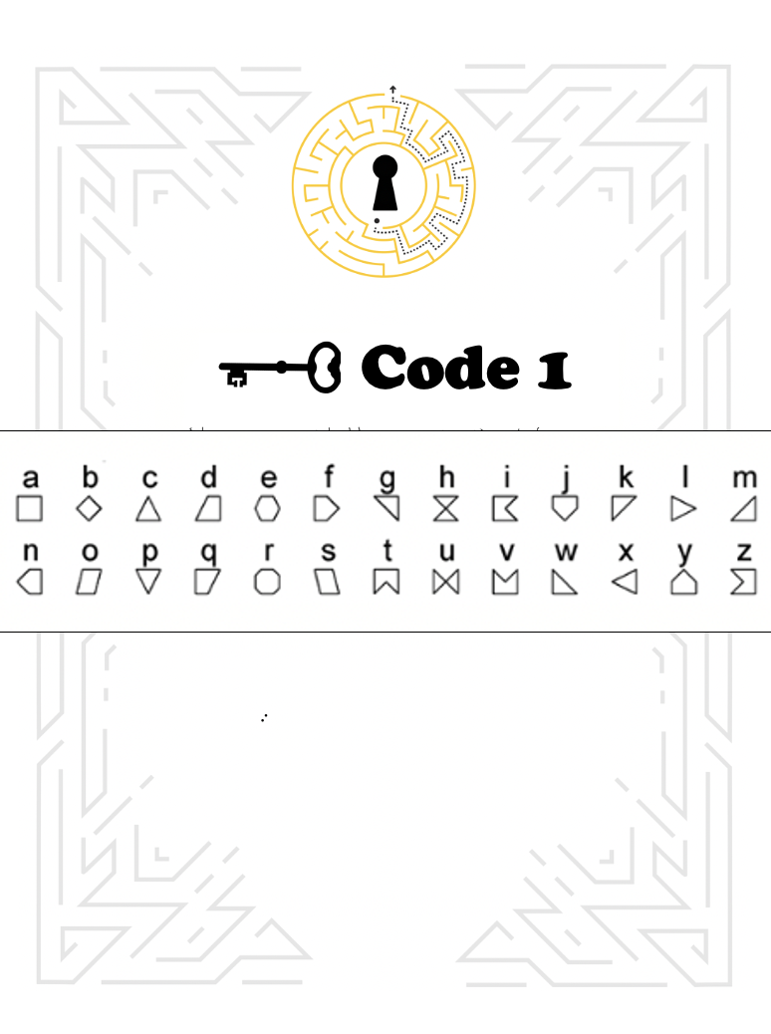
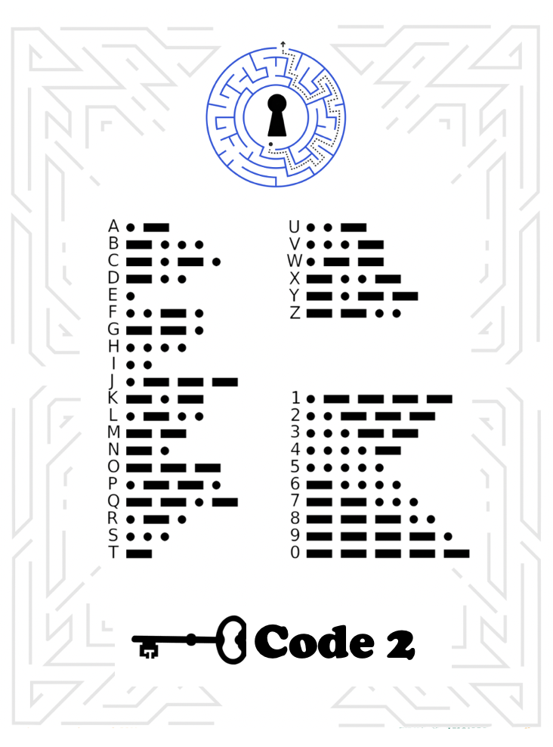

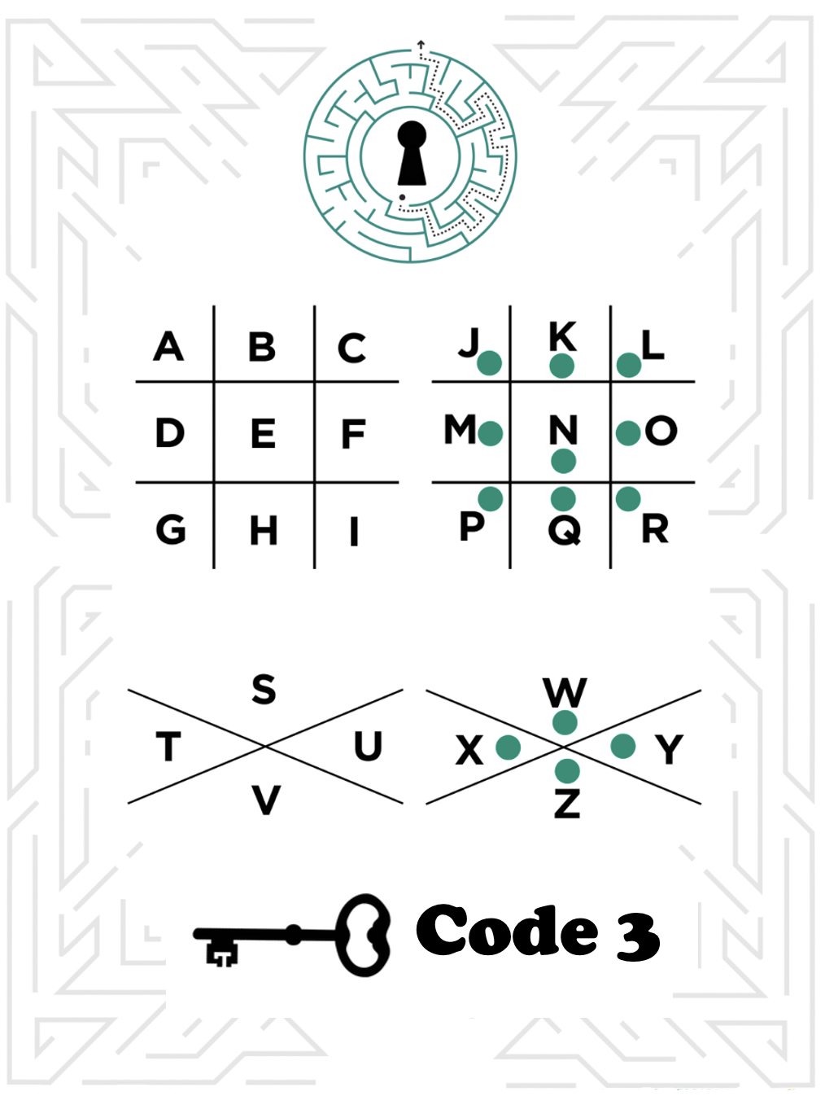
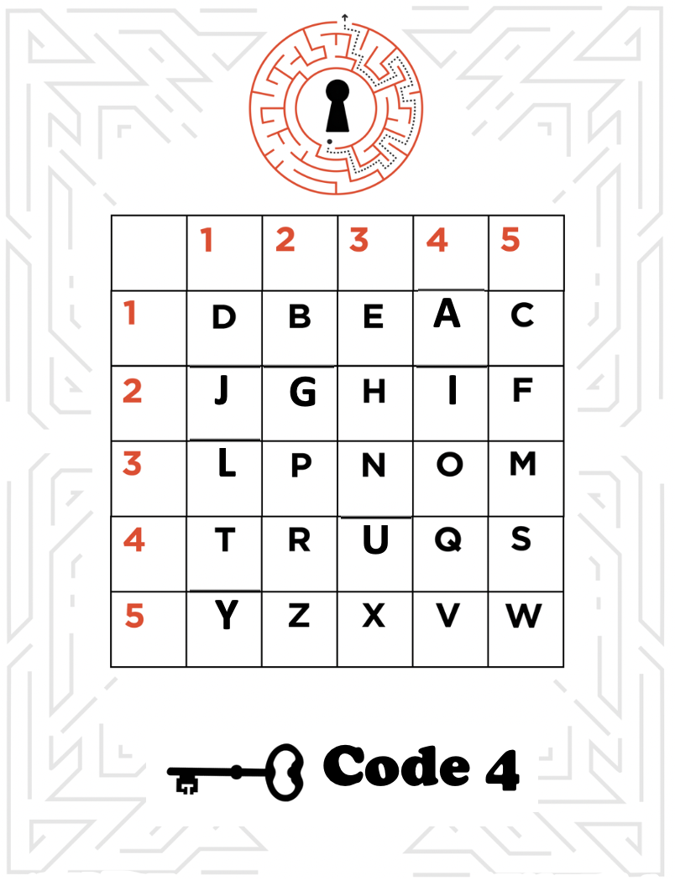

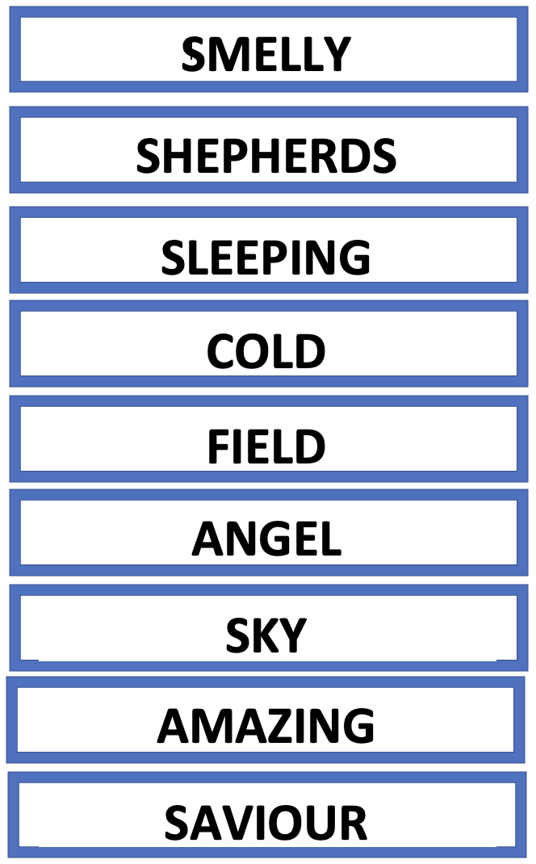
Code 5

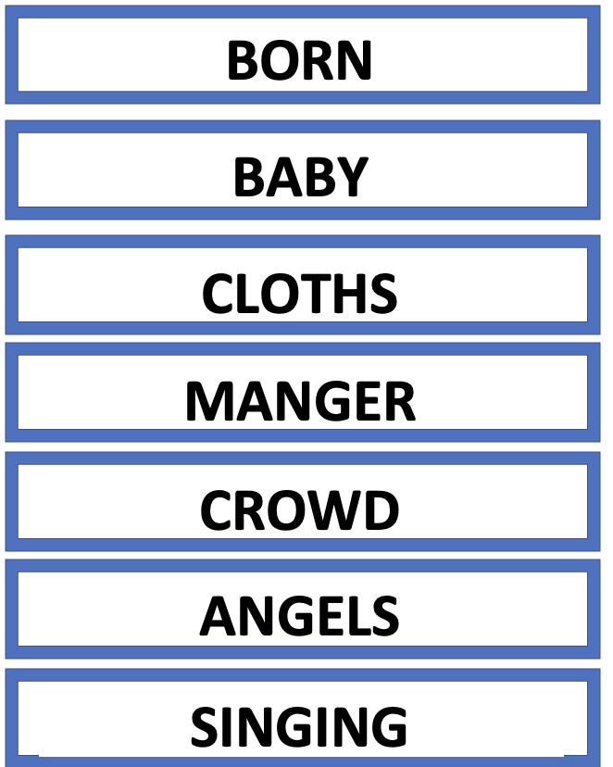

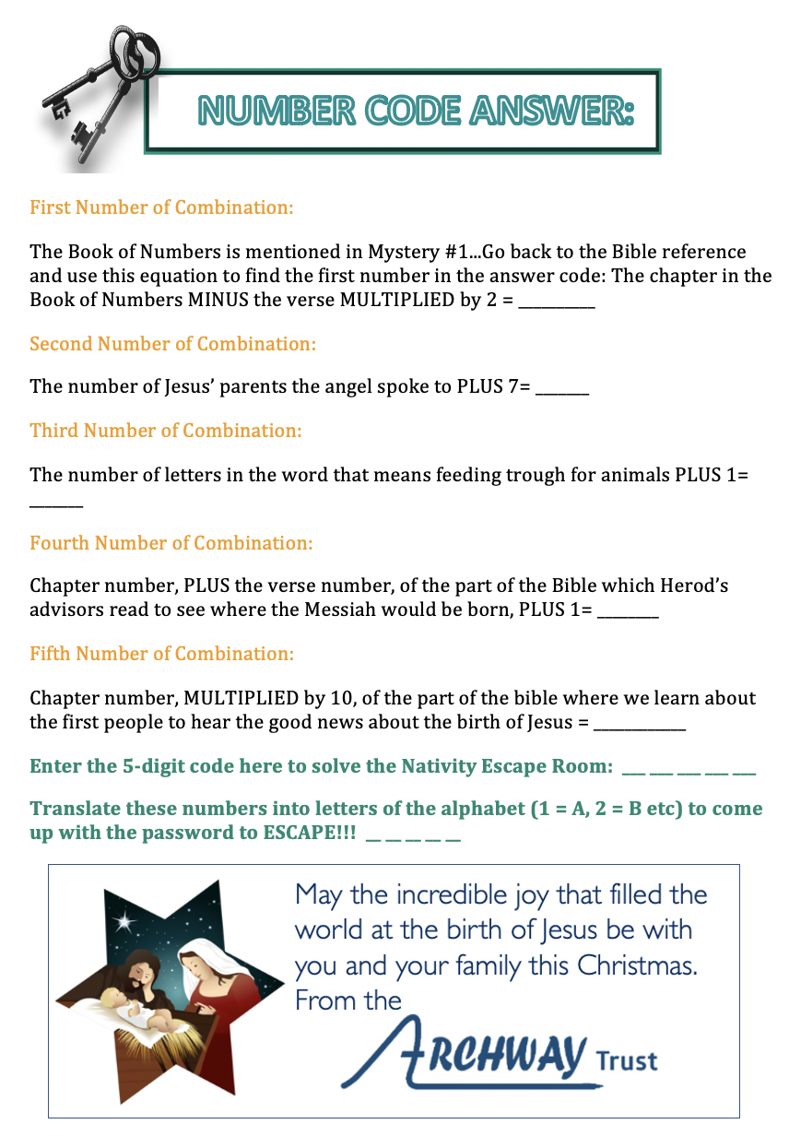

Answer Sheet
Mystery 1:
- Bethlehem
- Egypt
- Birth
- I God spoke to them in dreams

Mystery 2:
- You will give birth to a Son and you are to call Him Jesus
- Save His people from their sins

Mystery 3:
- Stable
- Manger
- He wanted to be just like you & me

Mystery 4:
- Iran / Iraq
- Palace …. Jerusalem
- God …. Creator …. Star ….. Name

Mystery 5:
The smelly shepherds were sleeping in a cold field when an angel suddenly appeared in the sky and told them that an amazing thing had happened, a Saviour had been born. He said that they will find the baby wrapped in cloths and lying in a manger.
Then a huge crowd of angels all appeared and started singing!!

Final Code:
12 9 7 8 20 = LIGHT

