Church of England Schools
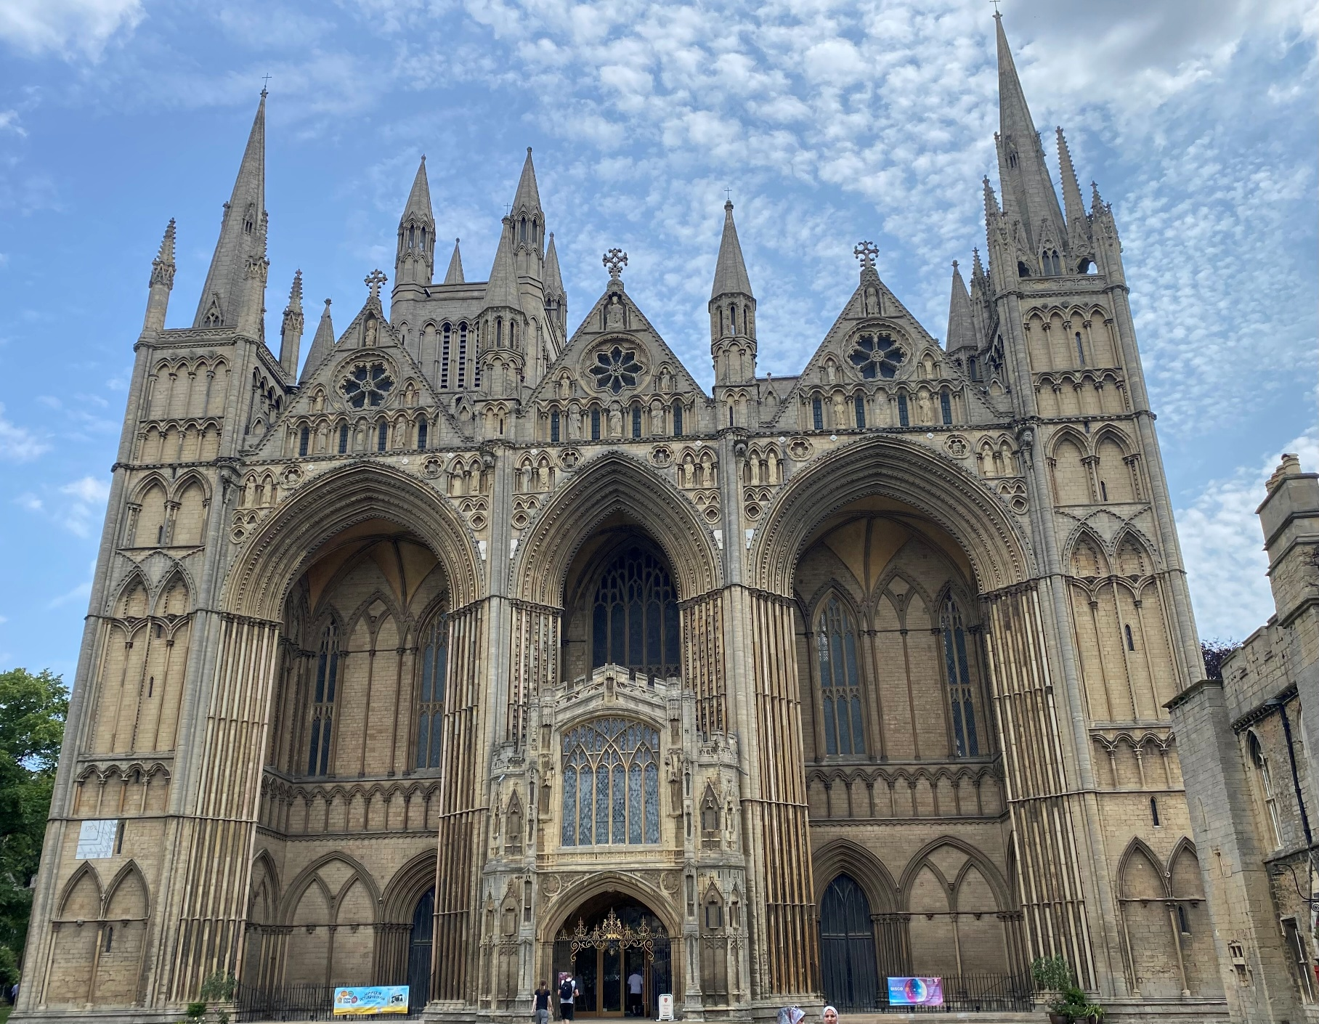
Peterborough Diocese

RE Newsletter
November 2025

INTRODUCTION

As the autumn term draws on and we begin to look towards Advent, there’s a sense of both gratitude and anticipation. The first half term of the year has been full of energy, creativity and deep thinking in RE across our schools. It’s been wonderful to see classrooms alive with conversation, curiosity and thoughtful reflection on the big questions of life and faith.
One joy for me this term has been returning to the classroom, leading RE Days and working with a Year 6 class to trial the Christianity as a Global World Faith resource ahead of our diocesan training. It is always a privilege to see first-hand how pupils respond, question, and grow through their learning. The Big Frieze and Balanced RE days have already proved rich in insight and engagement, and I look forward to developing new opportunities exploring Spirituality in RE, Pupil Reflections in RE, and Faith in the Connected World for secondary schools.
Religious Education continues to offer pupils something rare: the chance to explore big questions, to see the world through different eyes, and to learn to listen and respond with empathy and respect. At its heart, RE nurtures understanding, curiosity, and hope—qualities we need more than ever as we approach the season of light and promise.
Thank you for all you continue to do to keep RE vibrant and meaningful in your schools. I look forward to the weeks ahead as we prepare for Christmas, with all its opportunities to reflect, connect, and celebrate the richness of our shared stories.
Wishing you a peaceful and hope-filled Advent season.

Ziggy Brown
Ziggy.brown@peterborough-diocese.org.uk
Phone: 01604 887039 - 07814146023

Subject to availability, I offer bespoke RE training, which is entirely cost free for all our Gold SLA schools covering areas such as RE subject leadership, curriculum knowledge (religious and non-religious worldviews), disciplinary knowledge, assessment, and a worldviews approach. Please contact me to book or discuss tailored support for your school’s RE development. 01604 887039 or email ziggy.brown@peterborough-diocese.org.uk .
CONTENTS

INTRODUCTION.…………………………………………………………………………………… 1
UPCOMINIG DIOCESAN RE TRAINING THIS TERM………….………………………….. 2
NATIONAL UPDATES AND OPPORTUNITIES……………..……………………………….. 3
UPDATE ON THE RE STATEMENT OF ENTITLEMENT …………………………… 3
PREPARING FOR SIAMS ……………………………………………………………….. 4
THE BIG SPRING SING………… ………………………………………………….…… 5
DIFFERENCE FOR PRIMARY AND SECONDARY SCHOOLS ………………… 5
INTERFAITH WEEK …………………………………………………………..………….. 6
REAL PEOPLE REAL FAITH ……………………………………………………………. 6
OAK NATIONAL ACADEMY ……………………………………………………………. 7
PRIMARY RESOURCES…………………………………………………………………………… 8
SECONDARY RESOURCES……………………………………………………………………… 9

DIOCESAN RE TRAINING THIS TERM


All RE training events and booking links for this term can be found below by clicking on each training listed. All sessions are free with your Gold SLA, and the RE Network meeting is open to all schools at no cost. We hope you’ll join us for these opportunities to connect, reflect, and grow together. For full details, please see the document on our website.
Primary RE Network Meeting  Thursday 6 November 2025  4.00pm - 5.15pm  via Zoom  Free for all schools | A termly online session offering updates on national and diocesan RE developments, and a space to share good practice across schools.  Special guest: Ishver Patel MBE from the Better Lives Foundation and Wellingborough District Hindu Mandir.
Understanding Christianity  Tuesday 18 November 2025  9.30am - 3.00pm  Bouverie Court, 6 The Lakes  Bedford Road,  Northampton NN4 7YD | An introduction to the Understanding Christianity resource, covering core concepts, the spiral curriculum, The Big Frieze and an initial look at planning. Then focusing on planning high-quality RE lessons, curriculum mapping, assessment and using the Global Christianity resource.
Retrieval in RE  Wednesday 3 December 2025 1.00pm - 3.00pm  via Zoom | A session to support children’s retrieval of their learning in RE, focusing on substantive knowledge, vocabulary and disciplinary knowledge.

NATIONAL UPDATES
UPDATE ON THE RE STATEMENT OF ENTITLEMENT FROM EMILY NORMAN, NSE
The statement is written in draft and has been ready for some time, however as we have yet to hear the outcome of the Curriculum and Assessment (Francis) Review it would be unwise for us to publish this for schools until we know what will be recommended for RE. We will therefore hold back on publication until we have been able to check that the expectations of the Statement of Entitlement still work within the government recommendations (or align accordingly). This is likely to be later in the Autumn term. As soon as this has been done, it will be circulated to you to start using with your schools.
For 2025-26, SIAMS will continue to inspect how schools are meeting IQ6 'with reference to the Statement of Entitlement' referring to the current 2019 SoE document. Schools will not be expected to show how they are meeting the new Statement of Entitlement until September 2026 in terms of SIAMS. We would hope, however, that once it is published schools will start to engage with the new document.

For your information, the key changes are around:
- A much more accessible format, making it more audience-friendly
- Aiming to reflect and enable best practice nationally
- Increased clarity around multi-disciplinary approaches, the different types of knowledge and the expectation to see diversity within religious and non-religious worldviews taught (including Christianity)
- Clear expectations of the ways in which schools and trusts are expected to work with dioceses
- More clarity of expectations at KS4 and 5
- Referencing and sitting alongside the National Content Standard which the NSE has endorsed (National content standard for Religious education IN England)

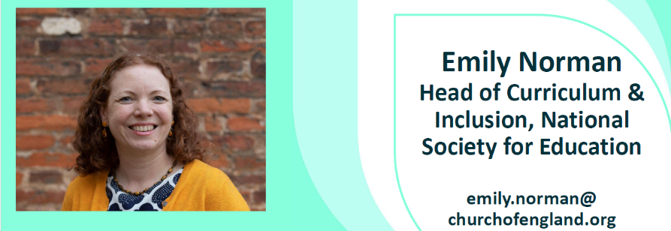
I hope this is helpful. If you would like any further information, please do not hesitate to contact me. I am now the main point of contact for all things RE in the NSE, so do let me know if there is anything I can help with.
Emily Norman, Head of Curriculum and Inclusion, NSE
As schools continue to reflect on their RE provision, the focus remains on ensuring all pupils, including those with SEND, access rich, inclusive learning that reflects religious and non-religious beliefs in their diversity.
PREPARING FOR SIAMS: DIVERSITY, INCLUSION AND GLOBAL CHRISTIANITY
We’ll explore this further in our network meetings when we will welcome speakers sharing their experience and the support they can offer schools (6th November 2025: Ishver Patel from Wellingborough Sanatan Hindu Mandir, 3rd March 2026: Caroline Wallace, Humanist School Speaker).
We will also offer training for schools to access the free NSE resource on ‘Christianity as a Diverse and Global Faith’ diocesan training on 22 April 2026.

For tailored support included with your Gold SLA, contact me at ziggy.brown@peterborough-diocese.org.uk.

Focus Area | Consider | Strengthen Practice | Possible Evidence
Global Christianity | Present Christianity as diverse and worldwide. | Include voices, art, and worship from different cultures. | Curriculum map, pupil voice, display photos.
Inclusion & SEND | Ensure ambitious RE for all learners. | Plan adaptive tasks and sensory, visual entry points. | Annotated planning, SEND work samples.
Curriculum & Legal Duty | Meet Entitlement and legal requirements. | Review curriculum annually; align to school vision. | RE policy, curriculum overview, governor minutes.
Balanced RE | Integrate theology, philosophy, and human/social sciences. | Map questions to all three approaches. | Medium-term plans, CPD notes, pupil work.
Monitoring & Evaluation | Regular review by leaders and governors. | Include RE in monitoring cycles and reports. | Learning walk notes, action plans, SEF evidence.
VA schools Q7 | Meet Trust Deed requirements; ensure theological depth. | Governors approve and monitor RE annually. | Governing body minutes, RE intent statement.

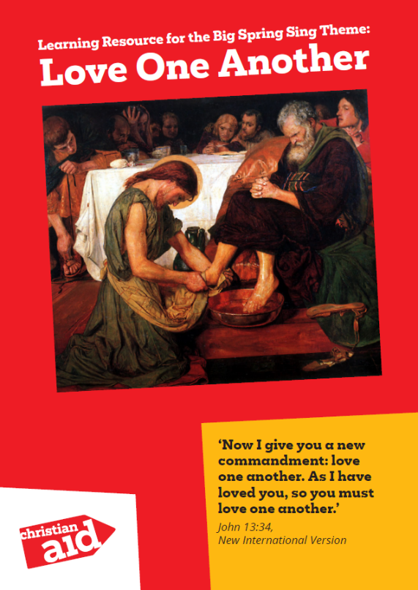
We are inviting schools to take part in this year’s Big Spring Sing, a joyful diocesan event that unites voices in song, hope and purpose. Together, pupils will form a large choir to celebrate the Easter message and help shine a light on global injustice through music and learning. Supported by Christian Aid’s Salvation activities and teaching resources, schools will explore the theme “Love One Another” (John 13:34), reflecting on how Jesus’ example of service and compassion inspires us to act for justice, equality and dignity in our world today. This is a wonderful opportunity for pupils to learn, sing and advocate for change, living out love in action and discovering that together, their voices can make a difference.
THE BIG SPRING SING
If your school would like to be part of this inspiring event, please share your interest with me here I’d be delighted to hear from you.
DIFFERENCE FOR PRIMARY AND SECONDARY SCHOOLS

We all want our primary schools to be places of belonging – where each child feels seen, heard, and valued exactly as they are. Amidst the competing priorities, rapid change, and the complex society we live in, it can be hard to know where to begin having honest conversations about our differences and disagreements.
On Tuesday 23 September, Difference for Primary Schools was launched. This is a free suite of resources to help your pupils navigate an increasingly complex world, inspired by Jesus to embrace difference and champion a culture of courage, hope, and empathy. Rooted in Christian values, Difference is designed to support real change by embedding three formational habits: Be Curious, Be Present, and Reimagine. Difference for Secondary Schools can be found here.

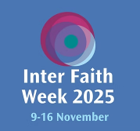
Community: Together We Serve 9 – 16 November 2025
INTERFAITH WEEK FOR SCHOOLS 2025
Join us for Inter Faith Week and give students in your school the chance to explore different faiths and beliefs, build empathy, and strengthen understanding across difference.
This year’s theme is Community: Together We Serve.
Inter Faith Week is a great opportunity to connect with local communities; understand how faith motivates people to social action; and explore how interfaith approaches can help build togetherness in the face of division.

On the 1st September, the new Interfaith Week for Schools Website launched. Keep in touch, share photos and let them know what you got up to in your school, SACRE or community, and help them spread the positive outcomes of linking faiths, beliefs and communities.

Access Inter Faith Week website.
Peterborough interfaith group: https://www.facebook.com/PeterboroughInterfaithCouncil/
Northampton Interfaith Forum (NIFF): http://niff.org.uk
REAL PEOPLE REAL FAITH – VIDEOS FOR KS1, KS2 & KS3

REAL PEOPLE REAL FAITH
A series of interviews filmed in locations across Berkshire, featuring local faith communities answering questions about their faith. Two questions, specific to each key stage were asked across the range of venues and in most venues, several people answered each question. This allows pupils and teachers to explore some of the diversity both between and within faith communities. The same six communities were interviewed at each key stage. Each film has a page of notes outlining the key questions and concepts, with a brief summary of the answers and some suggested follow-on activities.


OAK NATIONAL ACADEMY
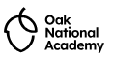
Oak National Academy announce that they have full curriculum resources for RE lessons, 216 lessons across 36 units from Year 1 to Year 6 as well as 18 KS3 units and GCSE exemplification for AQA, Eduqas and Edexcel!

The resources were written by primary and secondary teachers. They have clear knowledge and also use ways of knowing to build up pupils disciplinary understanding.
They have used case studies that show religious and non-religious worldviews are living traditions that have changed and adapted in modern Britain. They have rich stories and scripts to support delivering lessons to your class.
They show the diversity of lived experience from looking at Hindu climate activism in Year 4 to studying religious rebels and feminist and black theology in Year 10!
All lessons contain slide decks, quizzes and extra information to help you deliver the lessons.
The resources are all FREE and ADAPTABLE so you can tailor them to your school and to your agreed syllabus.

For any more information please contact Adam Robertson at adam.robertson@thenational.academy
Primary RE resources
https://www.thenational.academy/teachers/curriculum/religious-education-primary/units
Key Stage 3 RE resources
https://www.thenational.academy/teachers/programmes/religious-education-secondary-ks3/units
Key Stage 4 GCSE resources
AQA: https://www.thenational.academy/teachers/programmes/religious-education-secondary-ks4-gcse-aqa/units
EDUQAS: https://www.thenational.academy/teachers/programmes/religious-education-secondary-ks4-gcse-eduqas/units
EDEXCEL: https://www.thenational.academy/teachers/programmes/religious-education-secondary-ks4-gcse-edexcelb/units

PRIMARY RESOURCES
VISITING PETERBOROUGH CATHEDRAL
Exploring Christmas Workshop: An immersive RE workshop for all schools
A flexible half-day or full-day experience designed for Key Stage 1 and lower Key Stage 2, bringing the Christmas story to life through interactive storytelling, creative activities, and reflection inside the Cathedral. It has been carefully developed to support the RE curriculum, encouraging pupils to:
- Develop knowledge and understanding of Christianity and Christian traditions.
- Explore key religious concepts such as Advent, courage, hope, and peace.
- Reflect on personal values and experiences, regardless of faith background.
The session is suitable for all schools, including those with no religious affiliation. Activities are accessible, inclusive, and encourage pupils to think about wider themes of kindness, courage, and community.
Choose your experience:
- Half-Day Session (£4.35 per child) – Pupils rotate through a carousel of five interactive activities exploring Advent, Mary and the Angel, the Wise Men’s gifts, the journey to Bethlehem, and the angels’ message of peace.
- Full-Day Session (£7 per child) – Includes the half-day carousel plus a creative Stained Glass Window Making workshop, where pupils design their own window inspired by the Cathedral’s beautiful glass.
💡 If cost is a barrier for your school, please talk to us – we are keen to make this experience accessible for all pupils.
📍 Venue: Peterborough Cathedral
🕒 Duration: Half-day (morning/afternoon) or Full-day option, ending at 2pm
👥 Suitable for: KS1 and lower KS2
Booking is now open for Autumn Term 2, 2025. Places are limited, so we recommend early booking to secure your preferred date.
To reserve a place or find out more, please contact:
📧 schoolvisits@peterborough-cathedral.org.uk 📞 01733 355315
We look forward to welcoming your school to the Cathedral for this special seasonal experience.
HEROES OF HOPE
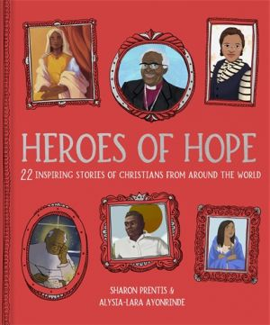
Heroes of Hope shares the true stories of 22 Christians from around the world whose faith inspired acts of courage and compassion. Written in a child-friendly style with reflection questions, it encourages pupils to think about how faith can bring hope and change.
THE JERUSALEM TRUST - RE GRANTS
SECONDARY RESOURCES
The grants can be used to support the purchase of teaching resources for Christianity in Religious Education in state primary and secondary schools in England and Wales.
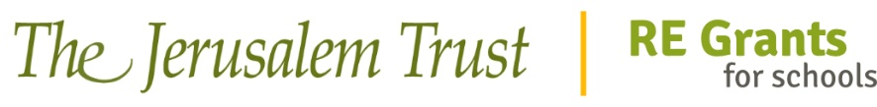
The grant application process is open for Secondary schools.
Click the picture for the link
DEVELOPING DISCIPLINARY ASSESSMENT IN RE
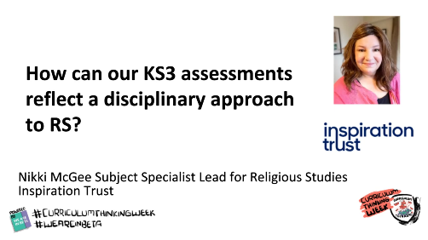
In this short presentation, the Specialist Lead for Religious Studies at the Inspiration Trust shares their work on reshaping KS3 assessments to reflect a truly disciplinary approach across theology, philosophy, and the social sciences. The talk demonstrates how assessments can capture what pupils can do—their ways of reasoning, interpreting, and questioning—rather than simply what they remember. Drawing on the work of Gillian Georgiou, Olivia Seymour, and the Ormiston Academies Trust, the speaker offers practical examples and candid reflections on workload, progression, and teacher moderation. Even without access to the linked resources, the video provides a rich insight into how a trust-wide RE community is deepening its assessment practice.
THE STORY OF THE JEWS
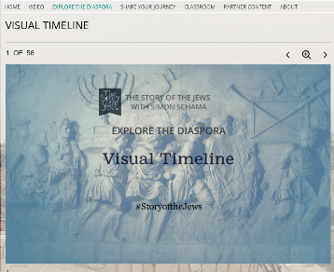
The Story of the Jews: Visual Timeline | PBS LearningMedia
This resource from PBS, produced with Simon Schama, provides a fascinating visual overview of Jewish history and tradition, including the Jewish community in the UK.
FACING HISTORY AND OURSELVES


Facing History and Ourselves (UK) is an organisation that supports schools and teachers to address the rising incidence of hate crimes through developing pupils’ understanding of racism, religious intolerance, and prejudice, increasing their ability to relate the lessons of history and literature to their own lives, and promoting greater understanding of their roles and responsibilities in a democracy. You can find out more about their resources here. Teaching Resources | Facing History & Ourselves.

