Creating the Class Schedule

The class schedule is created as a word document formatted to display within a browser window.

To create a new schedule, take a copy of a previous schedule and select Save As.
Give the schedule a new name of the form:

DBE Training Schedule YY-YY Version X-X

Where YY-YY indicates the years covered by the schedule e.g 21-22 for 2021 to 2022 and X.X is the version number of the training schedule starting at 1.0.
Enter details for each class / training session into the schedule document.

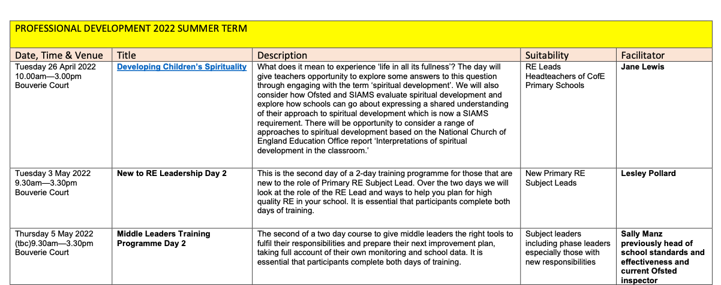

Date, Time And Venue: | The date, time and venue for the session should be entered in the first column.
Title: | The standard Name of the course.  This will later be replaced by a link to the associated Google booking form.
Description: | A description of the session and it’s contents
Suitability: | Details of the audience for whom the course is appropriate e.g Teachers, Headteachers, Governors etc.
Facilitator: | A list of the individuals who will be delivering the training.

Change the Title of each session to a link to it’s associated booking form.
Standard booking forms have been created for each course within the Google Forms Account.
The spreadsheet here contains a list of all courses and their associated forms.
Copy the URL of the correct form from the spreadsheet. (See ‘Obtain a Link to A Booking Form’ for information on how to find the correct link.

- Highlight the title of the session.
- Select Link
- Paste the web address of the Google Booking Form into the address field and press OK.
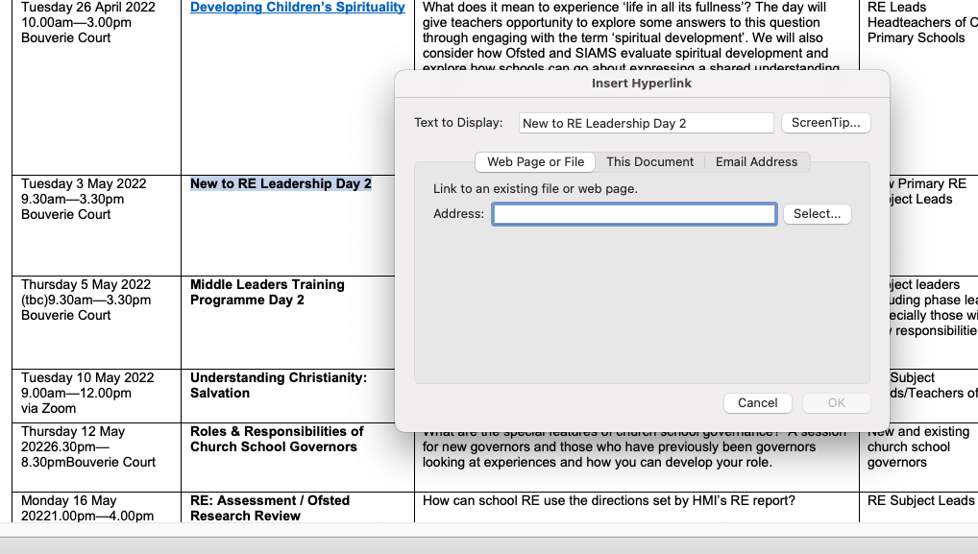

Remove any Classes from the schedule that have expired

Save the schedule with a new version number and update the link in the Diocese Website to point to the new version.

- Click the Save As Icon
- Enter a new name and save the document
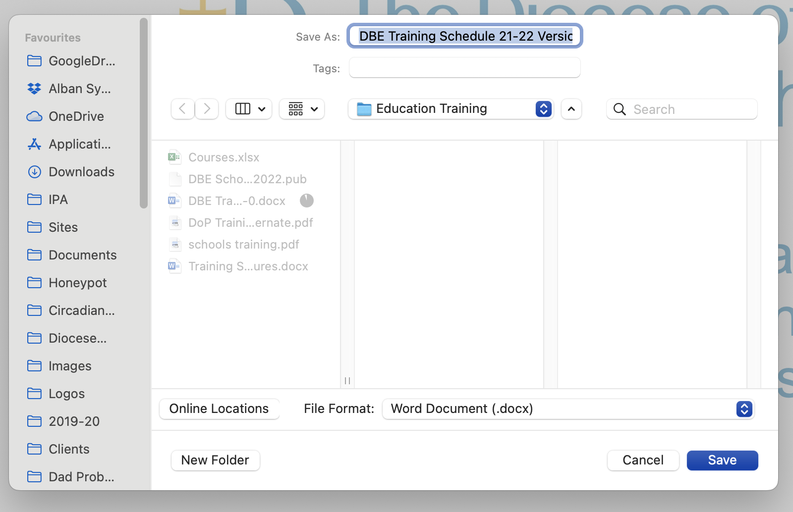

- Download a PDF version of the document.
- Upload the latest PDF version to the Diocesan Website.
- Change the link in Church Schools to point to the latest version of the training schedule

Managing Expired Classes
The Education training schedule needs to be kept up to date to avoid individuals booking onto classes that have already taken place and/or been cancelled.

It is therefore important that the schedule and class booking forms are maintained on a regular basis.
Overwrite items in the schedule

Highlight the table rows of any courses that have expired and click the ‘Strike Through’ button from the toolbar to show that course is no longer valid.

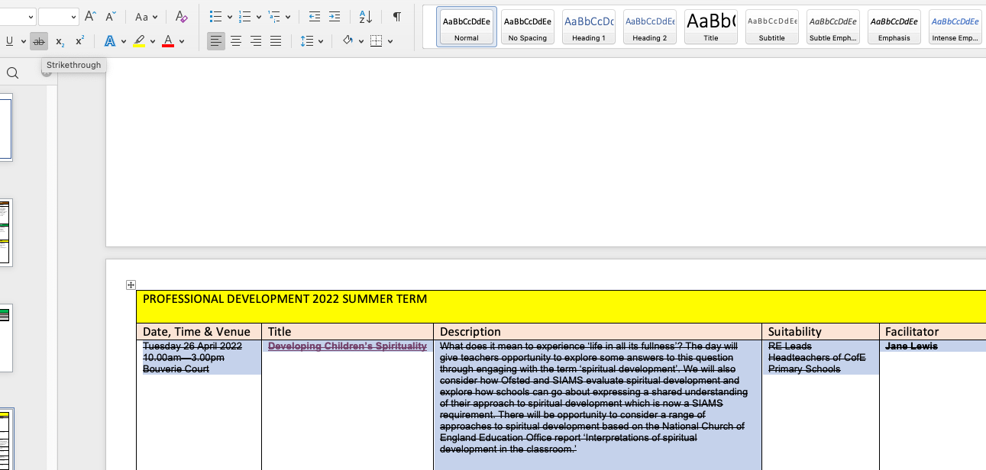

It may also be advisable to remove the hyperlink from the title to stop people from trying to book the course.

Highlight the linked text and select Link -> Remove Link

Creating a new Booking Form

- Log into the Google account EducationTraining@peterborough-diocese.org.uk.
- Select the Google Drive application
- Open the Booking Form Templates folder
- Open the form named ‘Template Online Booking Form’
- Click on the three dots icon and select ‘Make a Copy’

Enter the name of the class for the new form in the pop up window and select the folder ‘Course Booking Forms
Then click ‘Make a Copy’
A new form will be created and opened for editing.

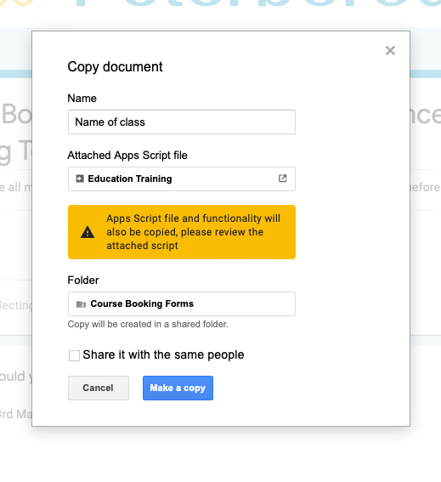

- Change the Title of the form to reflect the class to which this form is related

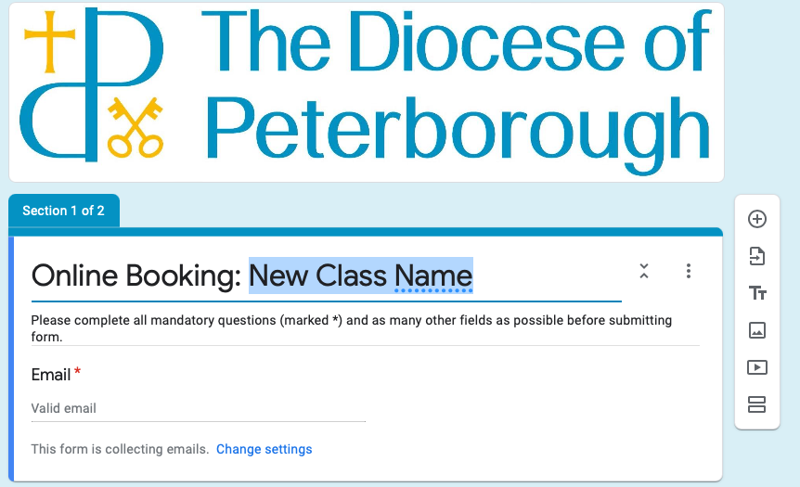

- Add the dates and locations of the courses

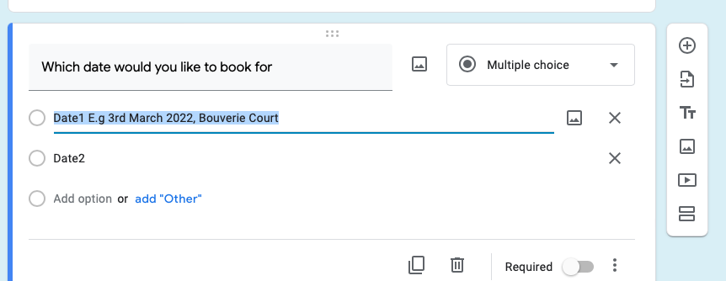

- Click on responses Tab, press the three dots Icon and select ‘Get Email Notifications for new responses’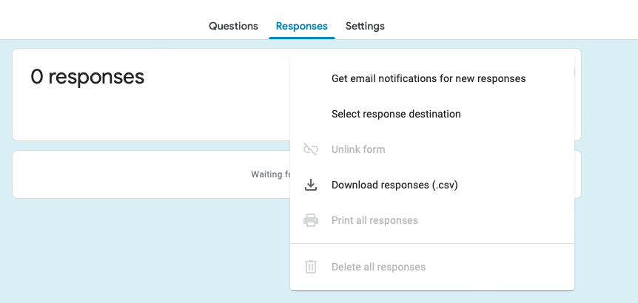

- Click on the three dots Icon again and click ‘Select Response Destination’

- With the checkbox ‘Create a new spreadsheet’ set click Create

- 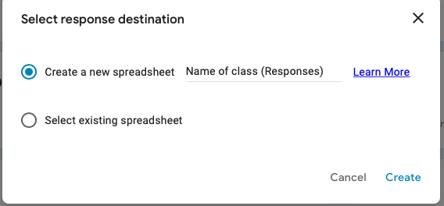

- The system will create a new spreadsheet to record booking data

- You can now close the form.

- In the Booking Forms folder you should see a Form and a Spreadsheet for the new class

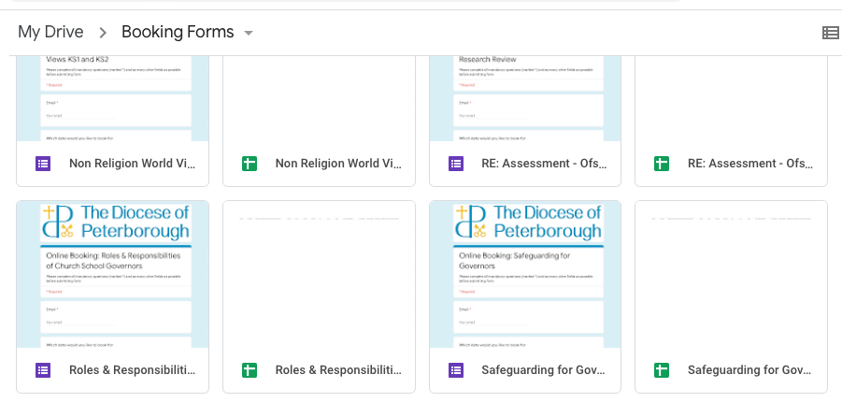

- Update the schedule and add calendar entries to point to the new booking form.

Managing Bookings

When a new booking is made by a user, an email should be received in the EducationTraining mailbox.

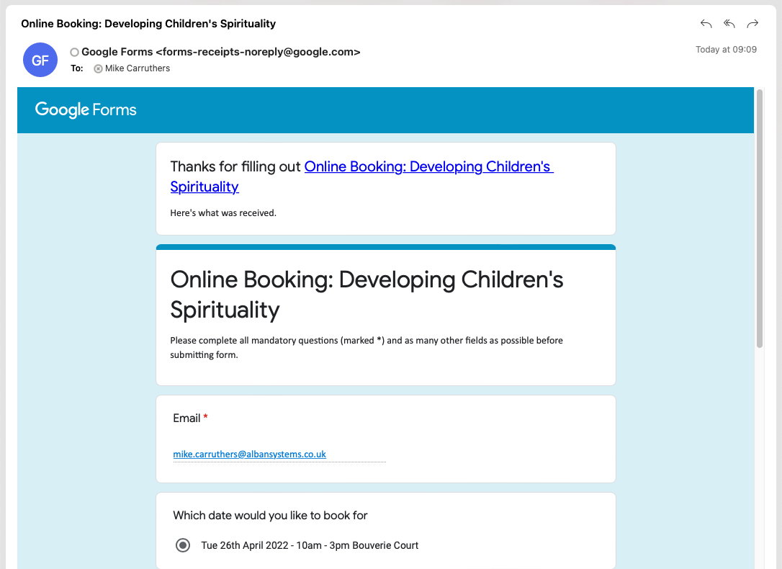

The email will contain all the information submitted by the user.
This data will also be recorded in the relevant responses spreadsheet.

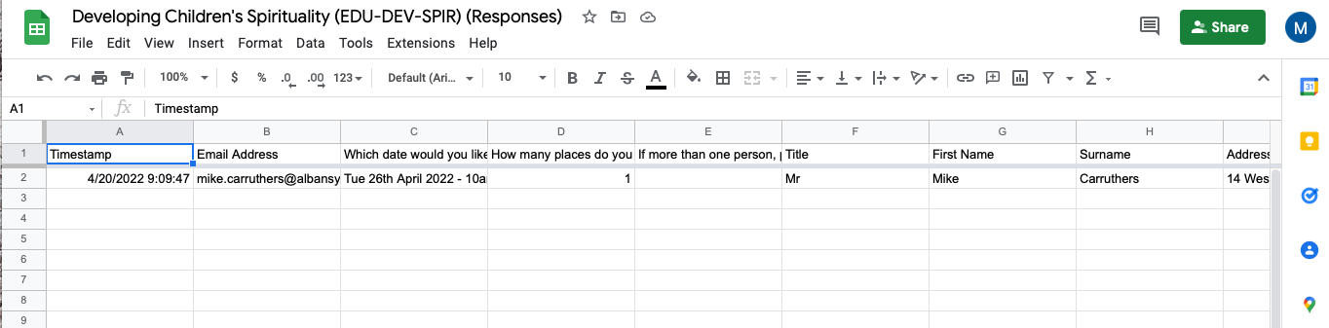

Process the bookings according to relevant procedures.

Changing / Adding class dates

When new classes are added to the schedule they should be included in:

- The class schedule document.
- The class booking form.
- The online training calendar

Class schedule
Edit the class schedule to add the relevant new training course/s.
Save a new vesion of the schedule document.

Create a PDF copy and upload to the website.
Change the links on the Education Training tile to point to the new document.
Booking Form
Log into the Google account for EducationTraining.

Navigate to the ‘Booking Forms’ folder and find the relevant booking form.
Add new date options, with time and location to the ‘Which date would you like to book for question’
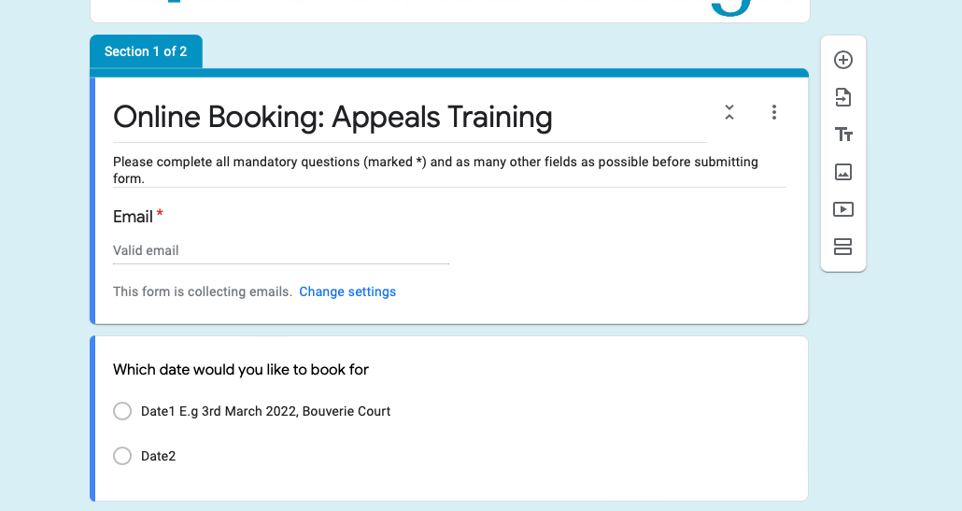

Once finished close the form.

Training Calendar

Add a new event entry in the online training calendar.

In ChurchEdit Global Office select Calendar and navigate to the correct date.

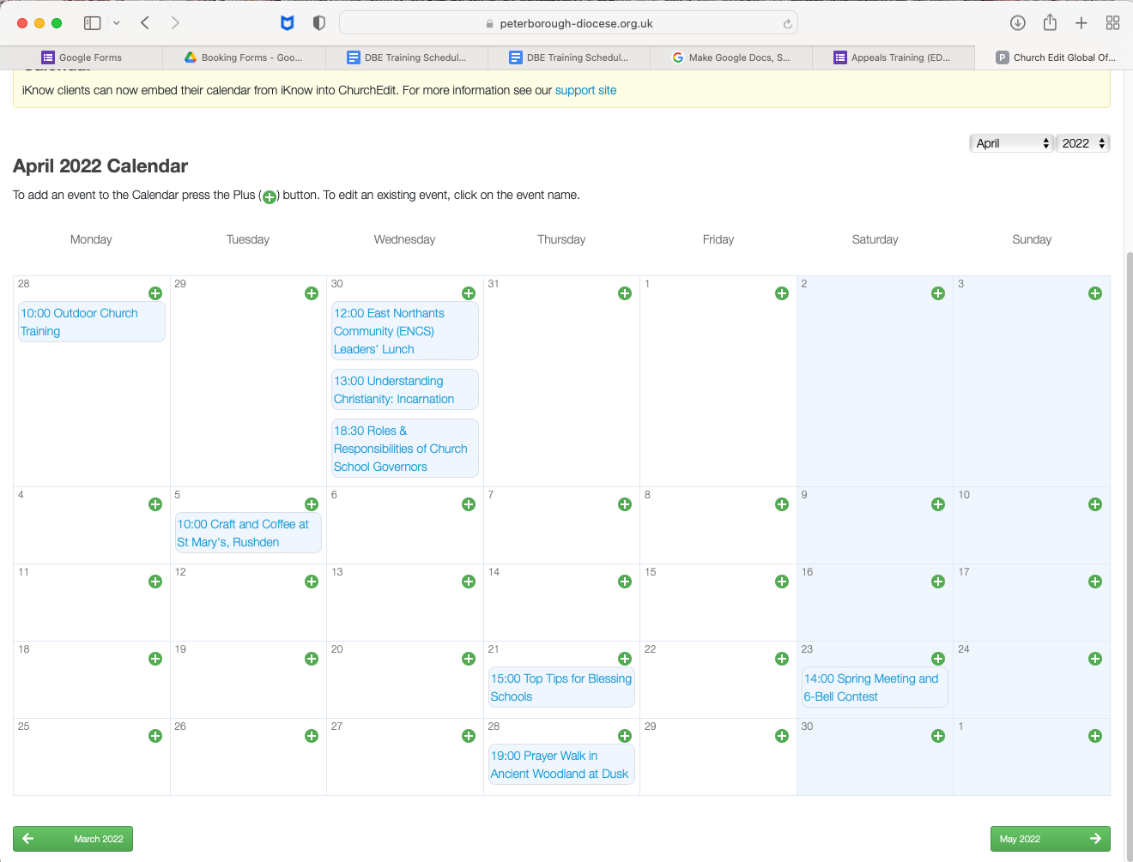

Click on the Green ‘Plus’ icon to create a new entry.

Set the Event Name, start and finish times for the training session and add all relevant information

Select the appropriate category for the training event.

Tick the ‘External Weblink’ option and paste the URL of the class booking form into the URL field.

Click the green ‘Add’ button.
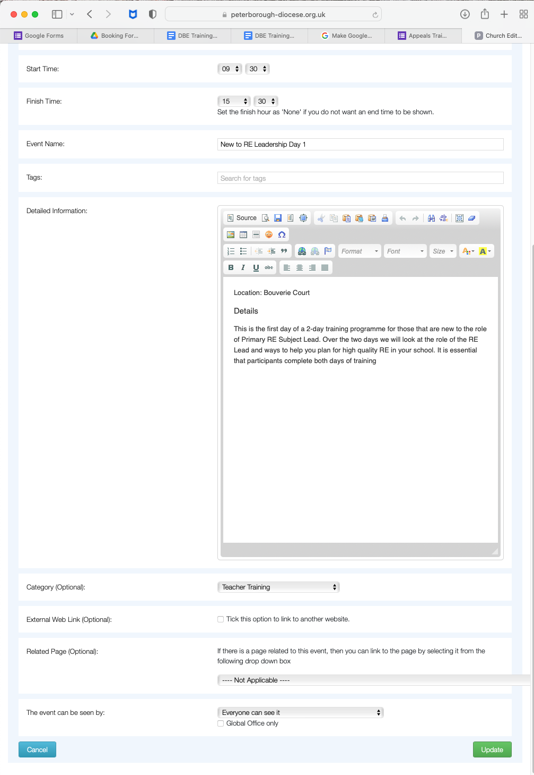

Adding new questions to the booking form

New questions may need to be added to the booking form in a number of circumstances.

- A new requirement to gather information for all bookings.
- A requirement to ask for additional information for a specific class.

The process for the second option is more straight forward.

- Log into the EducationTraining@Peterborough-Diocese.org.uk in Google.
- Select the Google Drive application.
- Open the relevant booking form from the BookingForms folder.
- Follow Googles Guide here on adding and editing questions.
- If the change affects the data that will be recorded by the form (i.e. you have added or removed a question), you may need to recreate the spreadsheet used to save booking information.

Select the ‘Responses’ tab from the form menu.

Select ‘Unlink Form’ to disconnect the form from the current data collection spreadsheet.
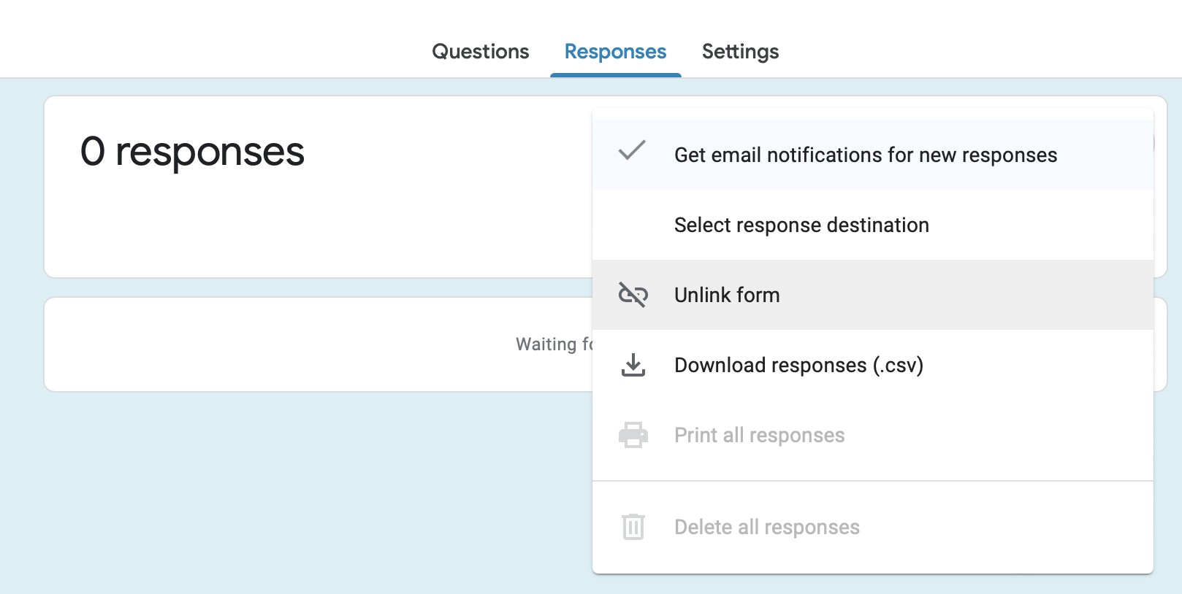

You will now need to create a new spreadsheet to collect the data.

Click ‘Select Response Destination’
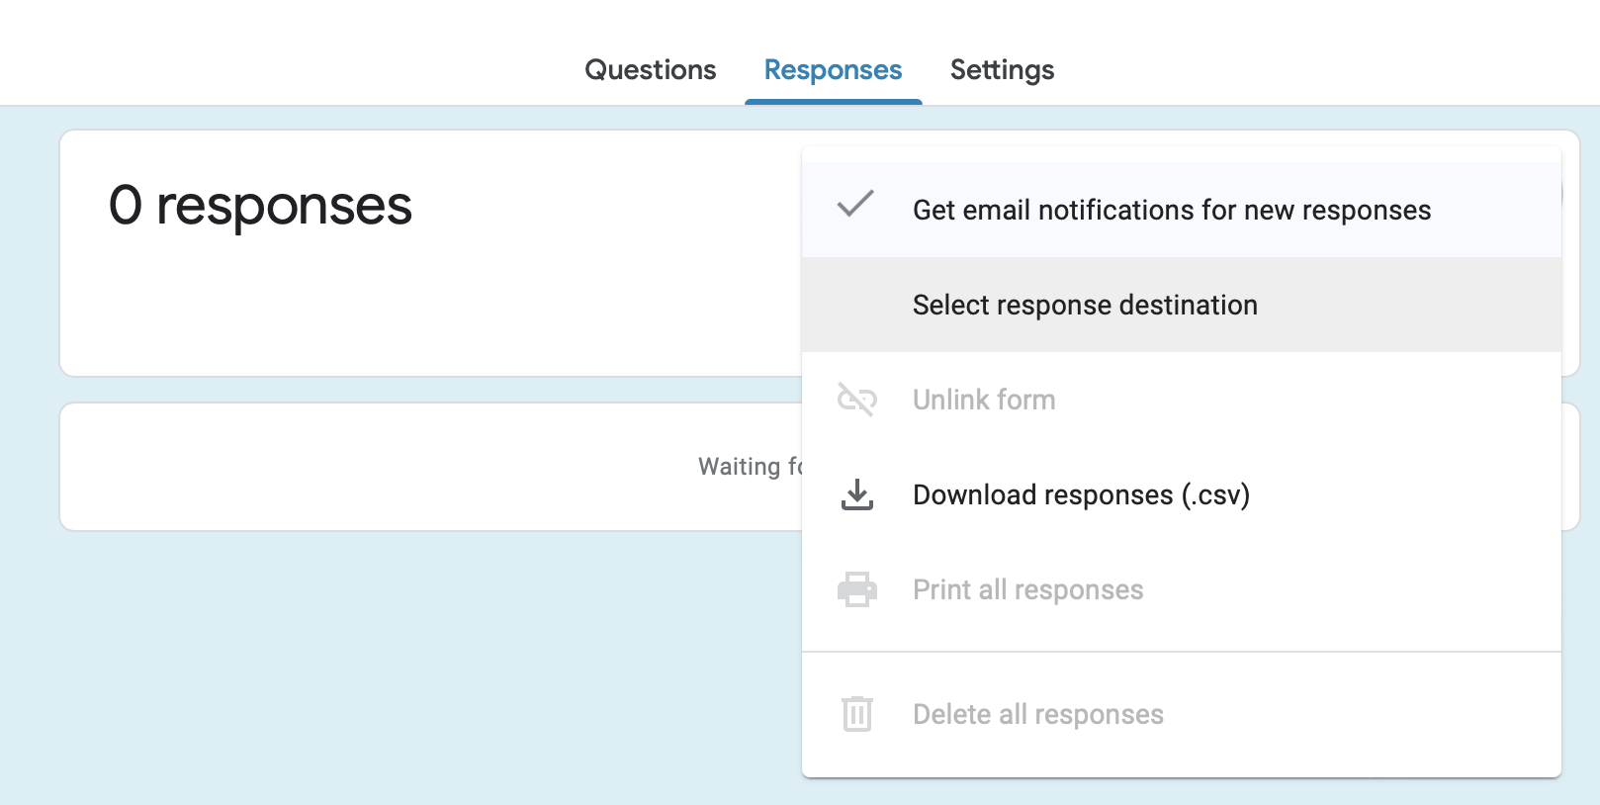

And leave the option to create a new spreadsheet selected.
Click ‘Create’

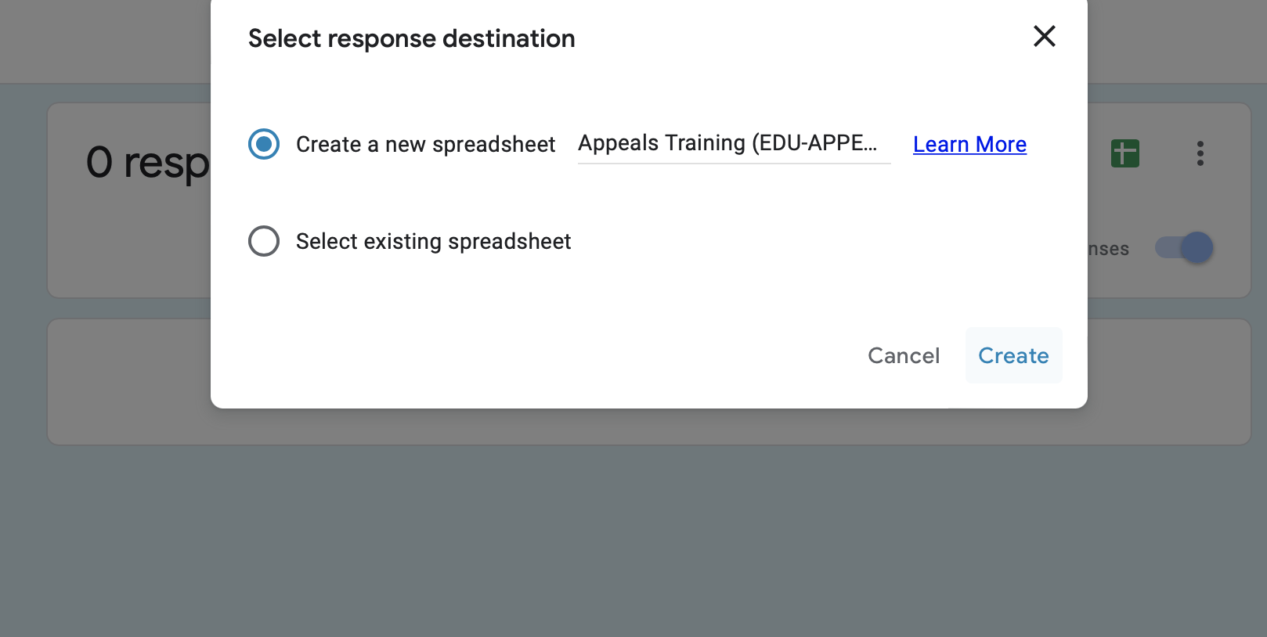

Close the form.

In the Google Drive folder you will now see two spreadsheets next to the form.

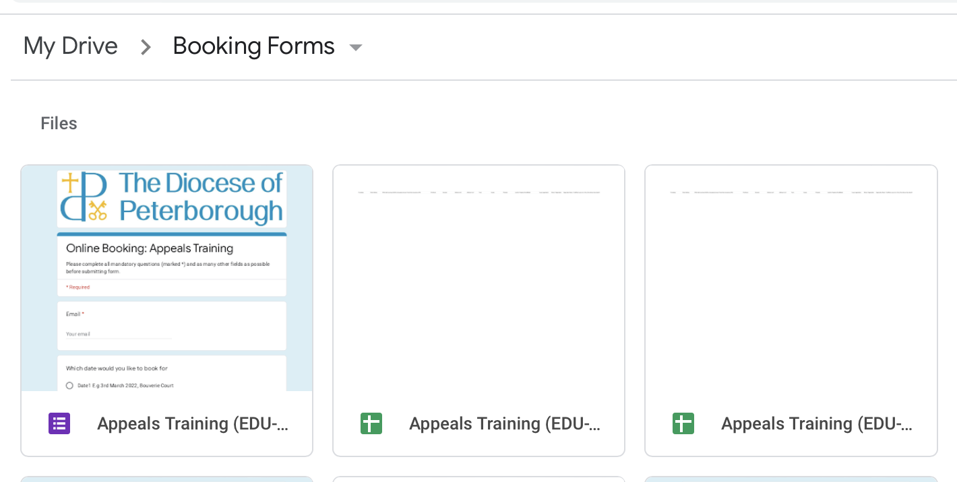

To avoid confusion, it may be better to move or remove the old spreadsheet having recorded any necessary information.

Obtain a link to a booking form

It may be necessary to obtain a URL link to a booking form to be used in the schedule, or added to a calendar entry.

Open the correct form in the Booking. Forms folder.

Click on the purple ‘Send’ button.

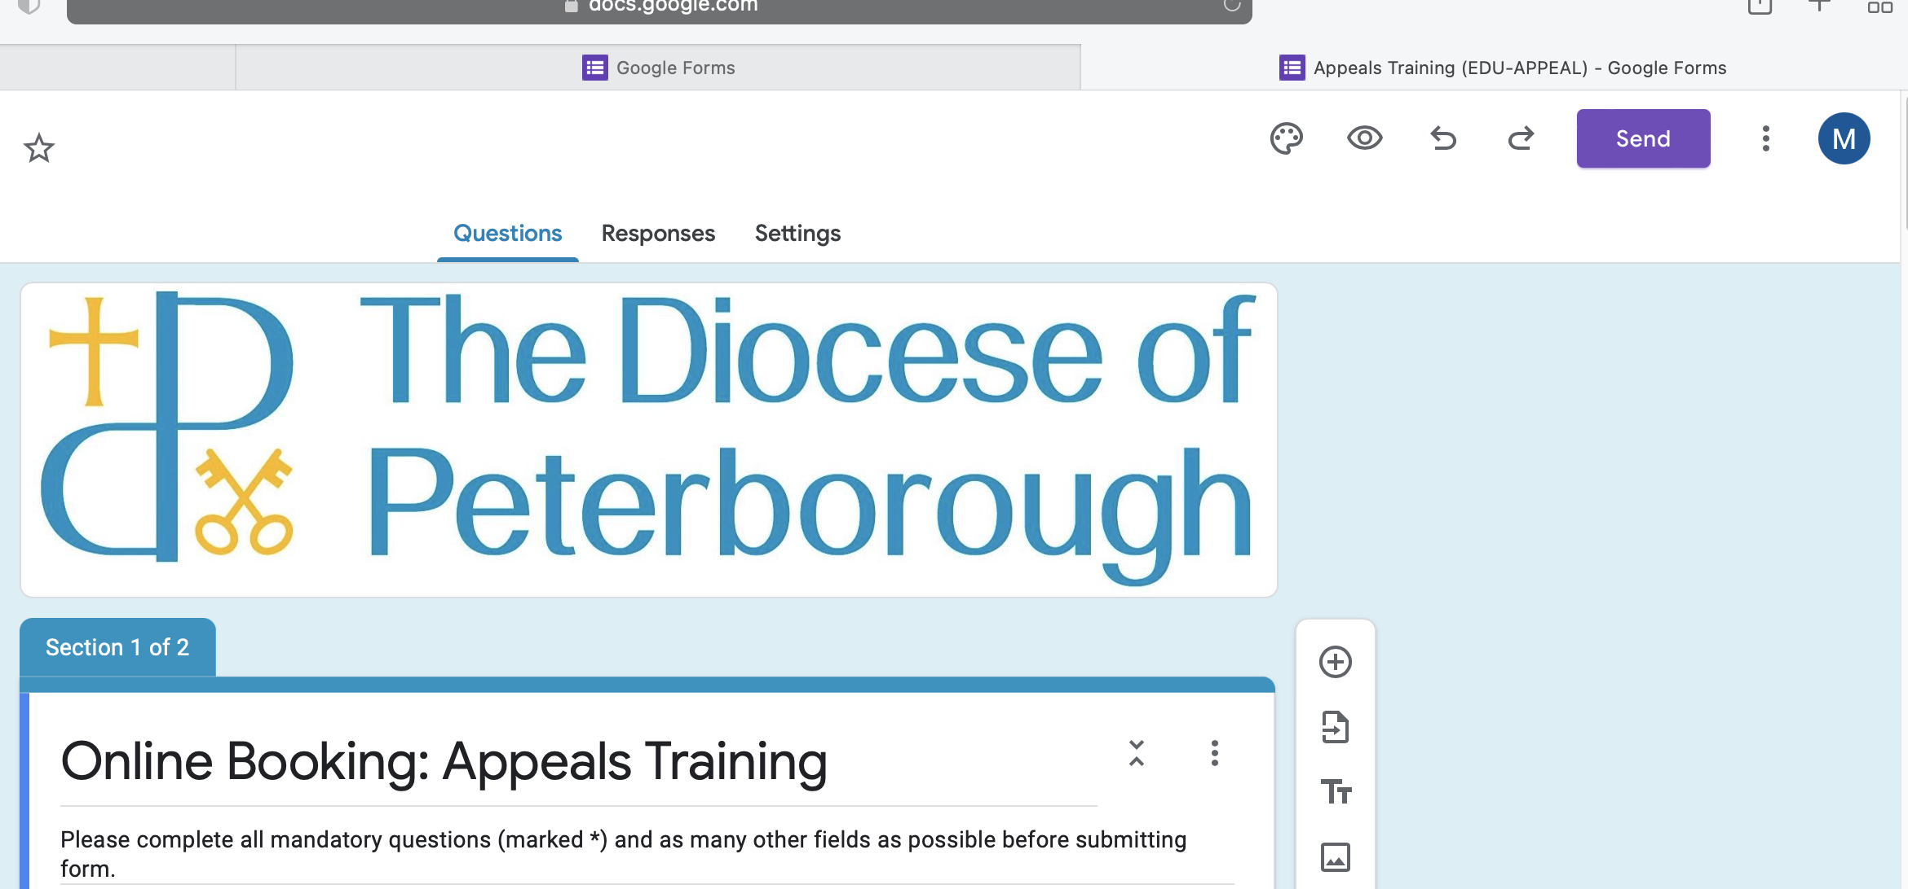

Select the link icon (chain) from the menu.

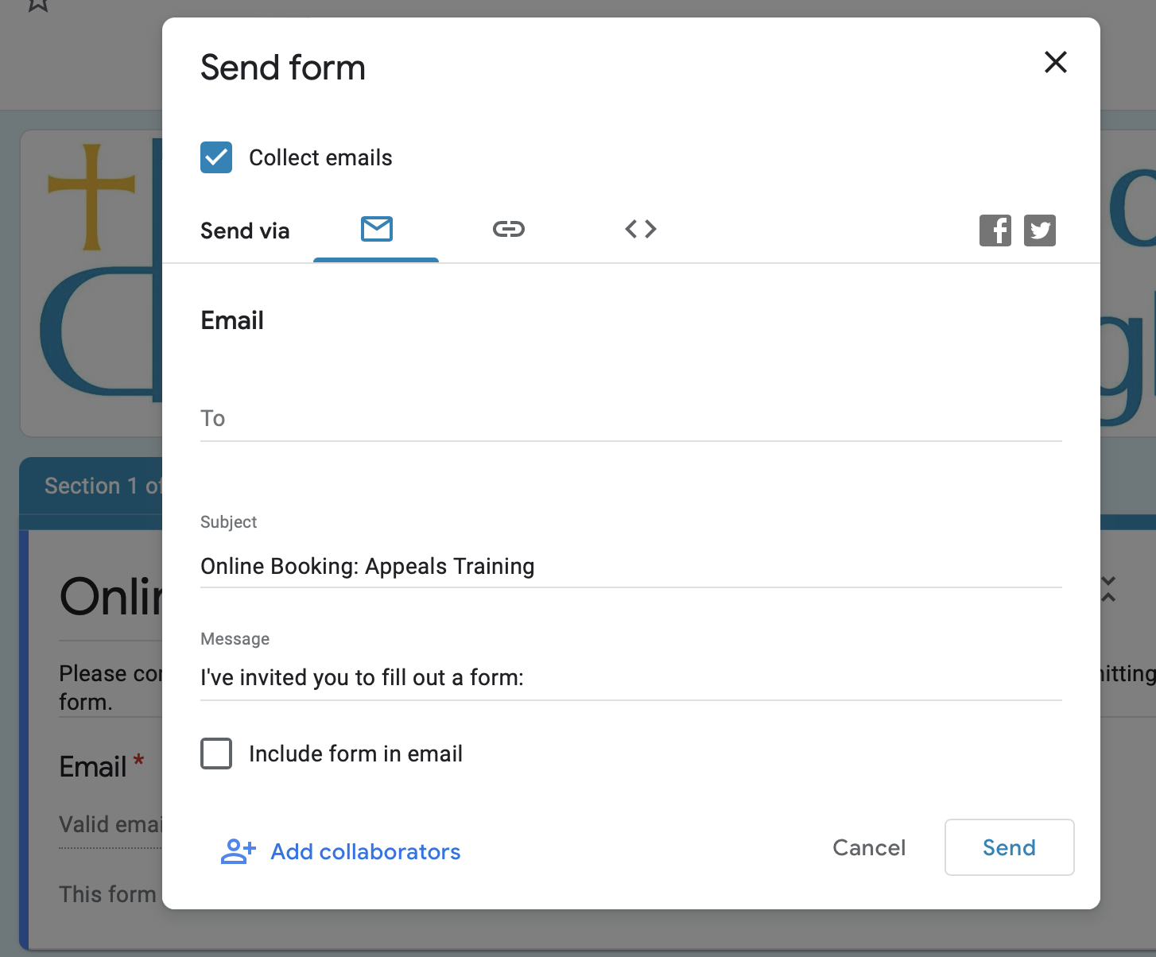

Tick ‘Shorten URL’.
Then press ‘Copy’ to copy the link to the clipboard.
You may now paste the link wherever it is required.

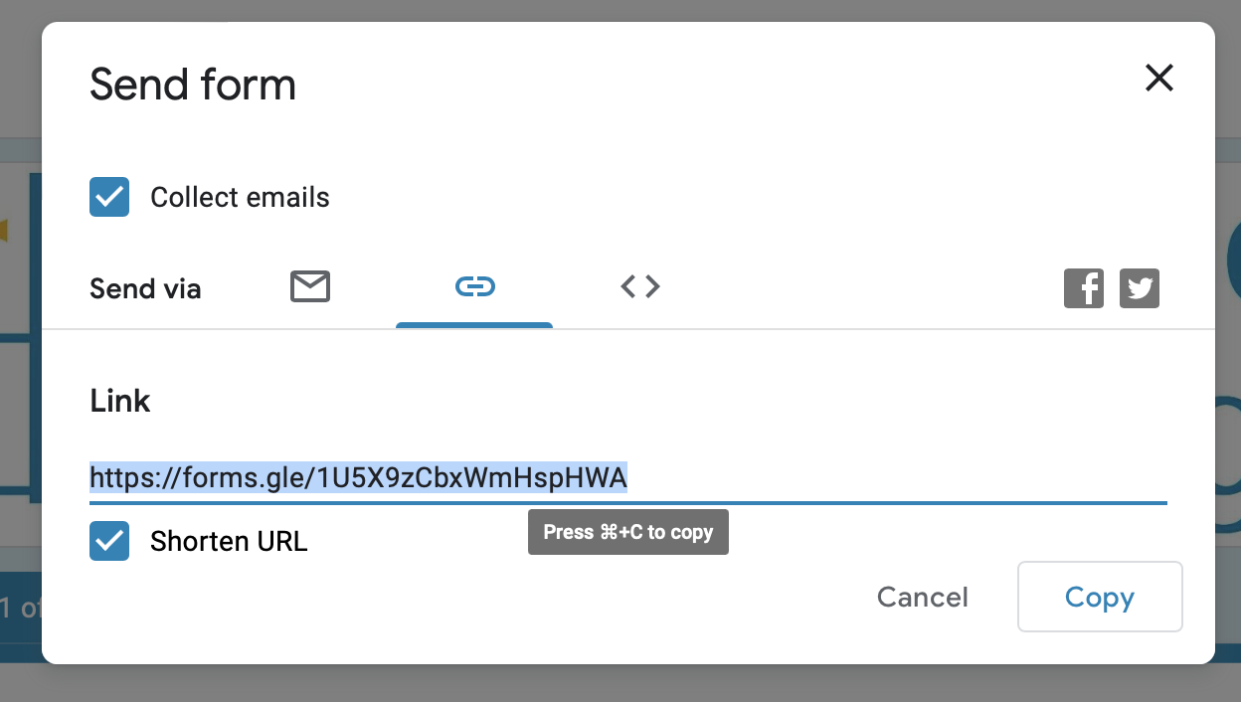

Download a file of responses from a booking form.

Open the booking form from the Google Drive ‘Booking Forms folder’.

Select Responses and click ‘Download Responses (.csv).
A file of response data will be downloaded to your PC.

